Casper User Manual
Table of Contents – PART 2: Casper eRegister
PART 2: CASPER eREGISTER
Chapter 1: Overview of CasperWeb 63
In this Chapter 63
CasperWeb Menus 63
CasperWeb Capabilities 65
Customer Information 65
Product Information 65
Options and Levels 65
Product Code 66
Site Key Generator 66
Prerequisites 66
Chapter 2: Using CasperWeb 67
In this Chapter 67
Serial Numbers 67
Log on to CasperWeb 68
Log Off CasperWeb 71
Navigation in CasperWeb 71
security considerations 72
Error Messages 73
Chapter 3: Managing Products 75
Set Up Products 75
Add Product Information 76
Modify Product Information 86
Delete Product Information 90
Set Up Executables, Options and Levels 93
Add Executable ID 93
Add Executable Version 98
Add Options and levels 101
Define License Types 112
Add a License Type 112
Add Product Codes 115
Product Setup Wizard 116
Product Code Browser 120
Chapter 4: Managing Customers 129
Add Customer Information 129
Edit Customer Information 136
Delete Customer Information 139
Display Customer History 140
Generate Site Keys 142
Chapter 5: Managing CasperWeb 149
User Maintenance 150
Add a User 150
Delete a User 153
Change a User Password from SuperUser Menu 155
System Maintenance 156
General 157
Email Server Set-Up 160
E-Receipt 161
Licensing via Email 162
Easy License 163
Auto Import 165
Chapter 6: Test Casper eRegister 167
Authorize your Casper Software 167
Test Casper Software using Company Data 168
Chapter 7: Reports and Administration 171
Admin Menu 172
Generate Reports 172
Change User Password from Admin Menu 175
Index 177

List of Tables
Table 2-1: Function Buttons in CasperWeb 71
Table 3-1: Executable ID – Data Entry Fields 95
Table 3-2: Executable Version -- Data Entry Fields 99
Table 3-3: Levels -- Data Entry Fields 104
Table 3-4: Options – Data Entry Fields 108
Table 3-5: Product Setup Wizard -- Data Entry Fields 116
Table 4-1: Customer Information—Data Entry Fields 131
Table 4-2: Site Key Generator —Data Entry Fields 145
Table 5-1: Add New User — Data Entry Fields 152
Table 5-2: System Maintenance/General Page/General – Data Entry fields 159
Table 5-3: System Maintenance/General Page/Database area – Data Entry fields 159
Table 5-4: System Maintenance/General Page/CasperWeb Login Information – Data Entry fields 160
Table 5-5: System Maintenance/Email Server – Data Entry fields 161
Table 5-6: System Maintenance/Licensing via Email – Data Entry fields 162
Table 5-7: System Maintenance/Easy License – Data Entry fields 164
Table 5-8: System Maintenance/Auto Import – Data Entry fields 165

List of Figures
Figure 1-1 CasperWeb Main Menu 64
Figure 2-1 CasperWeb Log In screen 68
Figure 2-2 License Status window 69
Figure 2-3 Log in to Main Menu 70
Figure 2-4 Multi-company License indicator 70
Figure 2-5 Log out message 71
Figure 2-6 Installation from Download password 73
Figure 2-7 Exception Error message 74
Figure 3-1 Family and Product screen 77
Figure 3-2 Add Family screen 78
Figure 3-3 Add Family – example 79
Figure 3-4 Add Family message 80
Figure 3-5 Select a Family and add a Product 81
Figure 3-6 Add Product screen 81
Figure 3-7 Add Product successful message 82
Figure 3-8 Add Product Version screen 83
Figure 3-9 Add Product Version message 84
Figure 3-10 Add Product Number message 85
Figure 3-11 Add Product Version and Number message 86
Figure 3-12 Edit Product description 87
Figure 3-13 Edit Product screen 88
Figure 3-14 Product description updated message 89
Figure 3-15 Product Number Description updated 90
Figure 3-16 Invalid Deletion message 91
Figure 3-17 Edit Product screen for deletion 92
Figure 3-18 Verify deletion dialog box 92
Figure 3-19 Executables, Options and Levels screen – Add Executables 94
Figure 3-20 Add Executable screen 95
Figure 3-21 Password required message 97
Figure 3-22 Executable added successfully message 98
Figure 3-23 Add Executable Version screen 99
Figure 3-24 Executable Version Added message 100
Figure 3-25 Executables, Options and Levels screen – Add Levels 103
Figure 3-26 Add Levels screen 104
Figure 3-27 Level added message 106
Figure 3-28 Executables, Options and Levels screen – Add Option 107
Figure 3-29 Add Option screen 108
Figure 3-30 Option added message 110
Figure 3-31 New Option is listed 111
Figure 3-32 Edit License Type screen 112
Figure 3-33 Add License Type screen 113
Figure 3-34 License Type added message 114
Figure 3-35 License Type updated successfully message 115
Figure 3-36 Setup Wizard screen – defaults 116
Figure 3-37 Add Product Code using Product Setup Wizard 118
Figure 3-38 Product Code Browser listing added Product Code 119
Figure 3-39 Product Code Browser screen 120
Figure 3-40 Product Code Add screen 121
Figure 3-41 Customer History showing HDSN 122
Figure 3-42 Add Product Code using Product Code Browser 123
Figure 3-43 Product Code added successfully message 123
Figure 3-44 Verify Product Code added 124
Figure 3-45 Product Code View screen 125
Figure 3-46 Product Code – modify details 126
Figure 3-47 Select Product Code to delete 126
Figure 3-48 View Product Code to delete 127
Figure 3-49 Verify Product Code deletion 127
Figure 3-50 Product Code list with deletion 128
Figure 4-1 Add Customer screen 130
Figure 4-2 Customer added 135
Figure 4-3 Customer added successfully message 135
Figure 4-4 Customer Serial Number search 136
Figure 4-5 Serial Number search results 137
Figure 4-6 Edit Customer screen—User fields 138
Figure 4-7 Edited Customer Information 138
Figure 4-8 Find Customer record to delete 139
Figure 4-9 Verify Customer record deletion 139
Figure 4-10 Customer Information screen 141
Figure 4-11 Customer History for specified Serial Number 141
Figure 4-12 Site Key Generator screen 143
Figure 4-13 Check Site Code test message 144
Figure 4-14 Manually generated Site Key 145
Figure 5-1 SuperUser menu 149
Figure 5-2 User Maintenance screen 151
Figure 5-3 Add New User screen 152
Figure 5-4 New User added successfully message 153
Figure 5-5 Delete User confirmation 154
Figure 5-6 User Deleted message 155
Figure 5-7 Change Password – from User Maintenance screen 156
Figure 5-8 System Maintenance – General 158
Figure 5-9 System Maintenance – Email Server 160
Figure 5-10 System Maintenance – Licensing via Email 162
Figure 5-11 System Maintenance – EasyLicense 164
Figure 5-12 System Maintenance – Auto Import 165
Figure 6-1 CrypKey Instant with Casper enabled 169
Figure 7-1 Administration menu 171
Figure 7-2 Reports screen 172
Figure 7-3 Expired Licenses Report by Day 174
Figure 7-4 Serial Numbers Report by Day 175
Figure 7-5 Change Password – from Admin menu 176

Chapter 1: Overview of CasperWeb
CasperWeb is your online interface for managing customer and product information.
C
asperWeb is an easy interface that allows you to access and manage your customer and product information, as well as maintain the system.

In this Chapter
In this chapter you will find information on:
- CasperWeb menus
- CasperWeb functionality
- prerequisites for using CasperWeb

CasperWeb Menus
CasperWeb is a web-based user interface. The main menu contains five submenus (see Figure 1-1 CasperWeb Main Menu). Each submenu contains links to these function screens:
- Customer Info
  - add and edit customer information
- Product
  - add and manage product codes
  - configure executables, options and levels
  - manage product families and products
  - specify the license type
  - use the setup wizard to quickly set up products
- Admin
  - generate reports (sales, expired licenses, authorizations, serial numbers)
  - specify the exchange rate (for credit card transactions)
  - change the user password
- SuperUser
  - configure users, set access levels, change passwords
  - configure email, database and CasperWeb log parameters
  - set up CrypKey eTransfer
- Contact
  - how to contact CrypKey
  - CasperWeb copyright information and website link
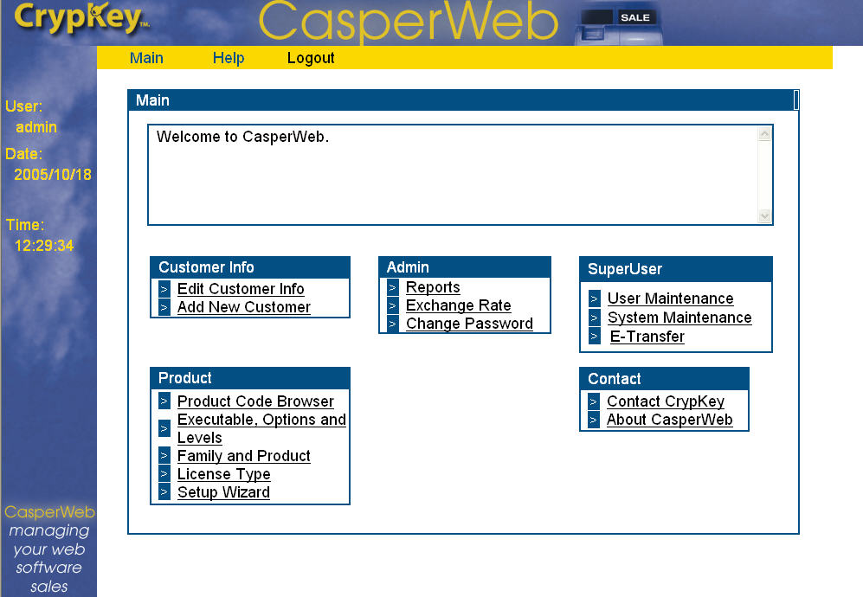
Figure 1-1 CasperWeb Main Menu

CasperWeb Capabilities
Using the CasperWeb interface, you can carry out the following tasks related to your business:
- configure product families, products, executables, license restrictions, and product codes
- record customer information, including Serial Number, customer name, customer number, product name, license restrictions, and invoice number
- apply and enforce restrictions on the use of your software
- generate a report of product license authorizations
- import customer, license, and product data

Customer Information
This function is central to the operation of CasperWeb. The key data field in customer information is the Serial Number, which represents the customer’s purchase of a specific product or add-on. Each customer record could contain essential data besides the Serial Number, including customer name, customer number, product identifier, license restrictions, and invoice number.
The Customer History feature displays the history of Site Key transactions by Serial Number (that is, by product and customer).

Product Information
The Product Code consists of information that you will use to organize your company’s products.
You must always include the three required fields when defining products: executable name/filename, password, and product number (see Product Setup Wizard on page 116.

Options and Levels
Options and Levels give you flexibility in licensing different options for an application.
An Option is a feature of the software that can be turned on or off in any combination. You can have one or more options enabled at the same time.
A Level is a set of features that is defined as ‘on’ when any single level is chosen. Only one level can be set at a time. See Add Options on page 101 for more information.

Product Code
The Product Code is a configuration of product family, product name, executable, license type, and other data items. A Product Code represents a specific software configuration (i.e. license usage restrictions) for which a customer could be authorized. A Product Code identifies this specific license configuration, which makes it easy to track in CasperWeb.

Site Key Generator
You can issue Site Keys manually to customers using the Site Key Generator. You can set the end user’s license restrictions by generating a Site Key manually. The Site Key Generator uses several types of information from CasperWeb, such as product family, product name, executable, and license type, to generate a Site Key.
An example of when you would issue a Site Key manually using CasperWeb is when your customer requests a license via telephone, fax, or regular email (i.e., not sending an email via the Client Interface Wizard program).

Prerequisites
- In order to use CasperWeb you will need an Internet connection and/or SMTP/POP3 email service.
- See Part 1: Setting Up Casper for a complete list of prerequisites needed to use Casper

Chapter 2: Using CasperWeb
The Serial Number is the key information used by CasperWeb to find and manage customer records.
C
asper is a real-time, Internet-based application with a design based on the client-server model.

In this Chapter
In this chapter you will find information on:
- Serial numbers
- logging on and off CasperWeb
- error messages
- navigating in CasperWeb

Serial Numbers
There are two methods of software authorization available in Casper: serial number and credit card. eRegister uses the serial number authorization method only. See Part 1: Setting up Casper, Chapter 2: Technical Help, Configuring Casper for more information. (eCommerce uses the credit card authorization method – see Part 3: Casper eCommerce.)
As the software vendor you provide Serial Numbers (based on whatever system you choose—see samples in the following sections). You provide these Serial Numbers to your customers. Casper issues software licenses to customers with a valid Serial Number. The customer enters the valid Serial Number into the Client Interface (see Part 1, Chapter 3: Getting Started, Client Demo Interface). CasperWeb uses the Serial Number to authenticate the use of your CrypKey-protected software before authorizing its use by your customer. Casper issues a license. The license contains the restrictions you assigned to the Product Code associated with the Serial Number.

Log on to CasperWeb
To log on to or exit CasperWeb, see the following procedures.
Procedure
- Open your Internet browser.
- In the address bar, type the online address of your CasperWeb server/CasperWeb. For example:
http://mycasper/casperweb
The Login window displays:
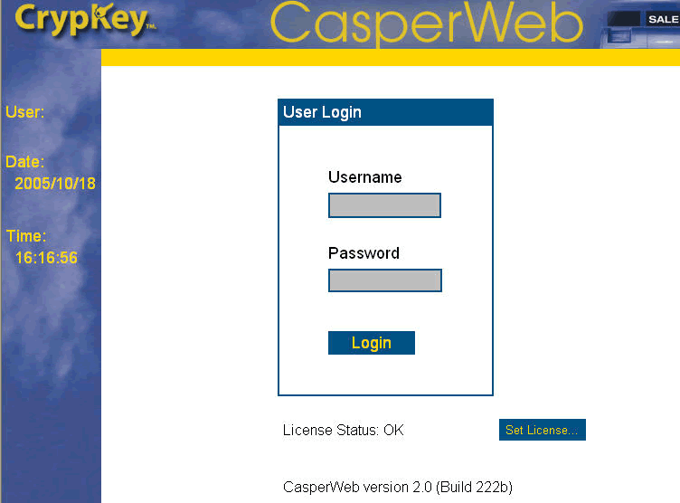
Indicates the status of your license.
Click to update license status.
Figure 2-1 CasperWeb Log In screen
- The license status will either read OK or it will prompt for a license automatically. If it does not, click the Set License button to view the following window:
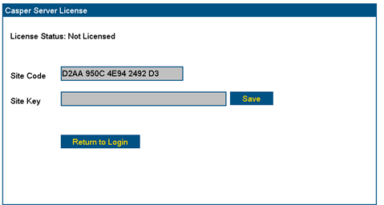

Enter Site Key.
Click Save.
Figure 2-2 License Status window
- The Site Code is displayed automatically. Enter the Site Key.
Note: To obtain a Site Key, send the Site Code to authorize@crypkey.com with your customer service number and company name. CrypKey Authorization will send you a Site Key.
- Click Save.
- Click Return to Login. The License Status should now read OK.
- To obtain the default username and password, contact CrypKey. Enter these two values. Note they are not case-sensitive.
Note: The username is admin; the password is the password that the user entered when they installed the Casper product.
- Click the Login button. The Main menu displays:

The SuperUser menu is available only to users with access privileges.
Click Main from any other screen to return to this window.

Click Help for descriptions of the function screens.
Click Logout to log out of the current session.

Click a link to go to a function screen.
Figure 2-3 Log in to Main Menu
- Click a menu option, for example Add New Customer, to go to that screen.
Note: In some of the following figures you may notice this text at the top of a screen:
Figure 2-4 Multi-company License indicator
This will be present only if you are using an optional multi-company license. A multi-company license is normally not used and therefore will not appear on your CasperWeb interface. It is included in this manual only for purposes of demonstration.

Log Off CasperWeb
Procedure
You can log off CasperWeb from any screen displaying the Logout option in the menu at the top of the screen.
Note: We recommend you always log out as a security precaution. CasperWeb will time out after a certain period of inactivity.
- Click the Logout option on the menu bar. CasperWeb displays the following message:
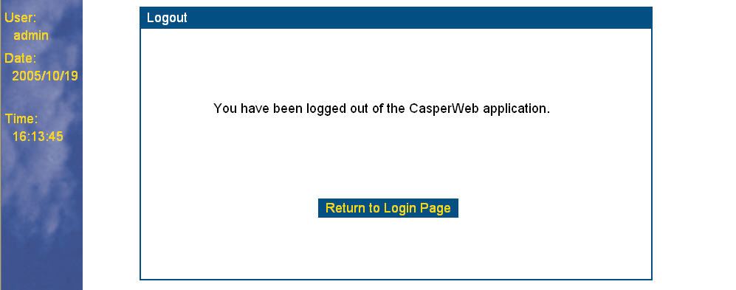
Figure 2-5 Log out message

Navigation in CasperWeb
The Main menu links to screens offering CasperWeb functions. Click on a menu link to open its screen. Screens contain a standard set of function buttons (see Table 2-1: Function Buttons in CasperWeb). Click the button to obtain the response shown in the table.
Table 2-1: Function Buttons in CasperWeb
Button | Function
Add | Adds a record of the specified type.
Back | Returns to the previously displayed screen (not necessarily the Main menu; to go to the Main menu, click on Main in the yellow menu bar at the top of each screen).
Create New | Creates new product code.
Create Product | Creates new product record with details you enter from the Product Wizard screen.
Delete | Deletes the specified record.
Done | Completes the creation of an added record.
Edit | Displays a detailed editing window for the applicable topic.
Find Serial/Name/Invoice | From the Customer Information screen, allows you to search for a customer record based on the serial number, customer name or invoice number.
Generate | Generates various reports from the Reports menu.
History | Searches on Serial Numbers, based on specified selection criteria.
Next | Advances to the next record (by alphanumeric sequence) of the type currently displayed.
Prev | Returns to the previous record (by alphanumeric sequence) of the type currently displayed.
Site Key Gen | Manual Site Key Generator.
Submit | Updates information within an existing Family, Product, Product Version, Executable, Executable Version, or License Type record.
Update | Updates information within an existing Product Code or Customer Information record.

security considerations
CasperWeb is a secure application. Communication can be set up to be sent using HTTPS, so that no one else can decrypt and view the contents of the page.

Error Messages
If you attempt an operation that is not permitted in CasperWeb, the system displays an error pop-up window such as the following:
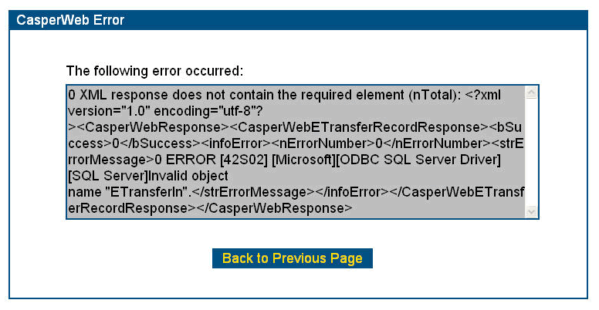
Figure 2-6 Installation from Download password
Try to interpret the error message and determine what action is necessary. If you have input an invalid value, click Back to Previous Page to refresh the screen where the error most likely occurred. Then correct the error and try your action again.
If you can’t determine the reason for the error message, please take a screenshot of the screen and email it to support@crypkey.com with your company name and customer service number for analysis.
Occasionally CasperWeb will display an exception error message, which looks like this:
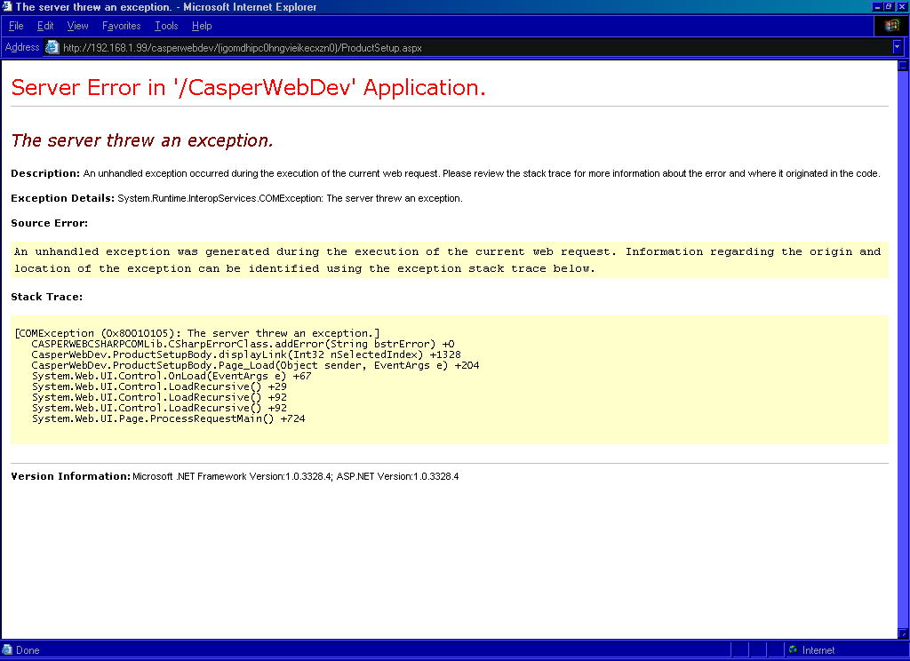
Figure 2-7 Exception Error message
Note: The appearance of the above window is no cause for alarm. The CasperWeb interface has simply timed out. There will be no loss of data. You need to return to the Login window and log in again.
If any exception screen appears consistently, we suggest that you take a screenshot of the screen and email it to support@crypkey.com with your company name and customer service number.

Chapter 3: Managing Products
Before you can process customer orders or issue software licenses, you need to know how to manage products.
I
n this chapter you will find information about:
- product information -- what a product consists of
- how to set up product codes
- how product codes are associated with Serial Numbers

Set Up Products
This section describes how to enter product information using the Product submenu options accessed from the Main menu.
Your product information must be entered into CasperWeb before you can process customer orders or issue licenses. Product information includes:
- Family (see Add Product Information below) — the overall product category
- Product (see Add Product Information below) — the product name, number, and description
- Product Version (see Add Product Information below) — the name and number of the product release
- Executable (see Add Executable ID on page 93) — the executable name and description
- Executable Version (see Add Executable Version on page 98) — the name and number of the executable release
- License Type (see Define License Types) — the name and description of the license type
- Product Code (see Add Product Codes ) — a unique alphanumeric code representing a product and its executable and License Type.
Note: The Product Code is not the same as the product. The product is the name of your product/application; the Product Code represents a unique relationship between a product, and product information such as the executable file and licenses. A product may have more than one Product Code, in order to represent more than one licensing option for that product.
You can query, add, modify, and delete the above information using the Product menu group that is accessible from the Main menu screen.
Note: The Product Number, Executable name, and Executable password must not be changed from the original information in the developer keys. Developer keys are specific to your company and product. Your company received the developer keys from CrypKey when you completed your evaluation of CrypKey Instant or CrypKey SDK. These keys do not change. Consequently, to make possible the continued licensing of the product, the three values on which the keys are based – the Product number, the Executable name, and the Executable password – must also never change.

Add Product Information
Procedure
This section describes how to add one or more families, products and product versions to CasperWeb. You add products and product families via the Product submenu, Family and Product option.
Before you set up individual products in CasperWeb, there must be at least one family (category) associated with the products. The Family field in the Add Product screen is used to create and maintain records defining product families. You do not have to create a family if you use the Product Setup Wizard--it creates a default family for you.
- Go to the Main menu (see Log on to CasperWeb on page 68).
- Under the Product submenu, click Family and Product. The Family and Product screen displays (see Figure 3-1 Family and Product screen).
- Beside the Family box, click Add to add a new record, or Edit to modify an existing record. In this example we will be adding a new family of products.
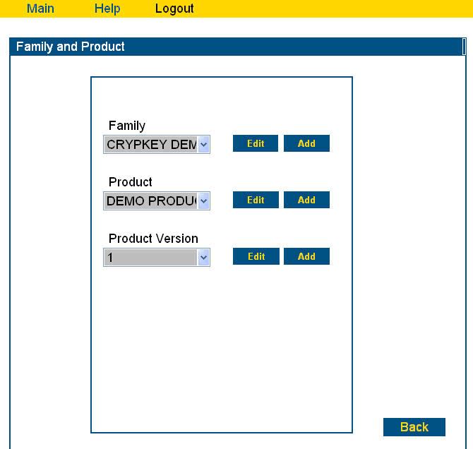
Click
Add.
Figure 3-1 Family and Product screen
- CasperWeb displays the Add Family screen:
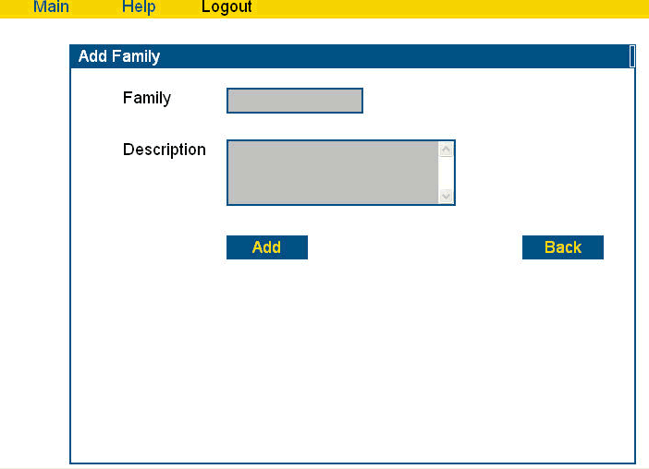
Figure 3-2 Add Family screen
- Enter your data. The screen below shows an example:
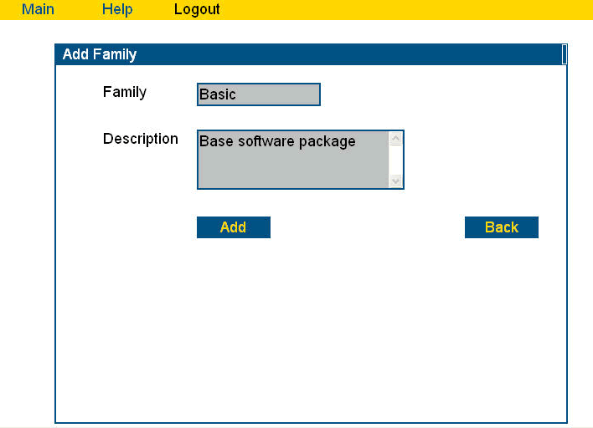
ClickAdd.
Enter family name and descrip-tion.

Figure 3-3 Add Family – example
- Click Add. If the action was successful, CasperWeb displays a message at the bottom of the Add Family screen:
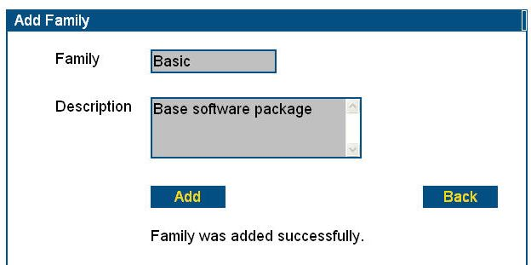
Addition successful message.
Figure 3-4 Add Family message
- Click the Back button to return to the Family and Product screen (see Figure 3-1 Family and Product screen
- Now you will add a product to the product family.
Note: A product can be associated with only one product family. Once a product has been associated with a product family, that relationship cannot be modified. To change the association, you must delete the product record, then recreate it and associate it with another product family. (See Modify Product Information on page 86.) You cannot delete a product if a Serial Number has been associated with it.

- From the drop-down menu beside the Family box, select the family you want to add the product to (i.e. the family you added in the previous step):
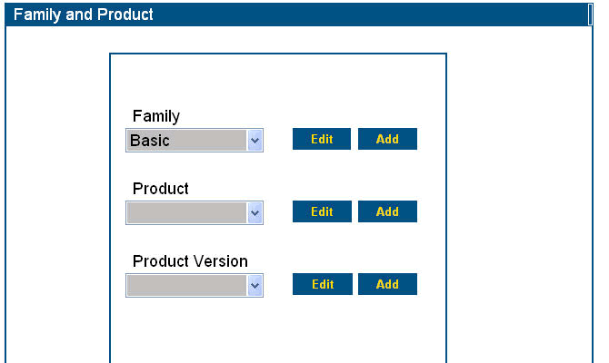
ClickAdd.
Select a Family.
Figure 3-5 Select a Family and add a Product
- Click Add beside the Product box. The Add Product screen displays:
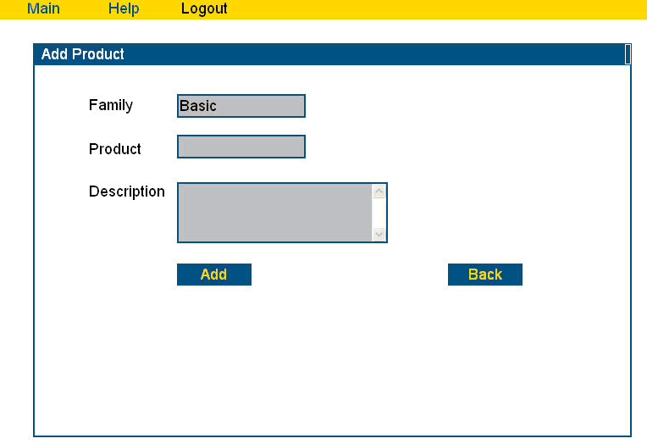
Enter Product name.
ClickAdd.
Figure 3-6 Add Product screen
- Enter the name of the product in the Product box.
- Enter a description of the product (optional).
- Click Add. If the action was successful, CasperWeb displays a message at the bottom of the Add Product screen:
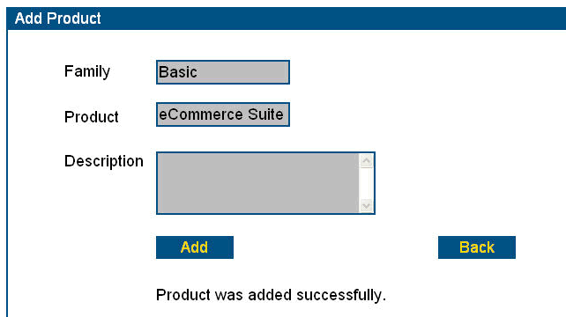
Successful addition message.
Figure 3-7 Add Product successful message
- Click the Back button to return to the Family and Product screen (see Figure 3-1 Family and Product screen.
- Now you will add the version of this product.
Note: You can set up any number of versions of a product.
- Click Add beside the Product Version box. The Add Product Version screen displays:
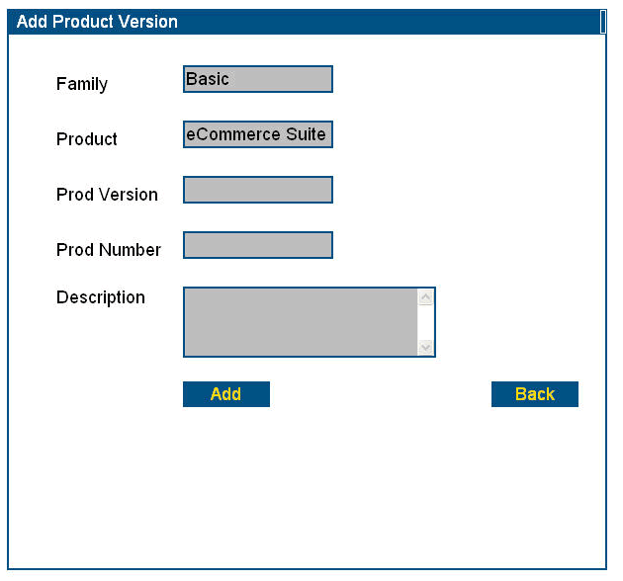
Product version required.
Product Number required.
Figure 3-8 Add Product Version screen
- You must enter both the Product Version and Product Number. If you click Add without first entering the Product Version, you will get an error message similar to the following:
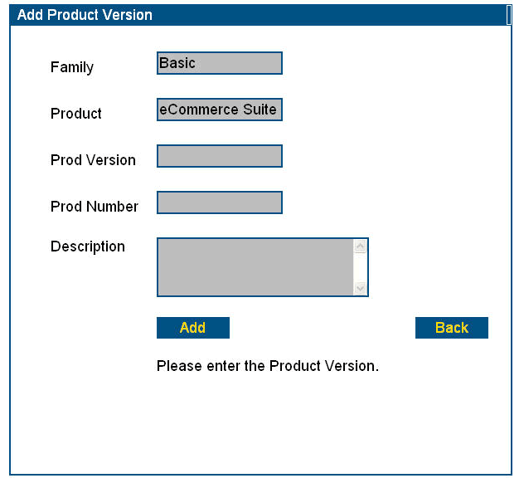
Product version required message.
Enter Product Version (alpha-numeric).
Figure 3-9 Add Product Version message
- Enter the Product Version.
- If you now click Add without first entering the Product Number, you will an error message similar to the following:
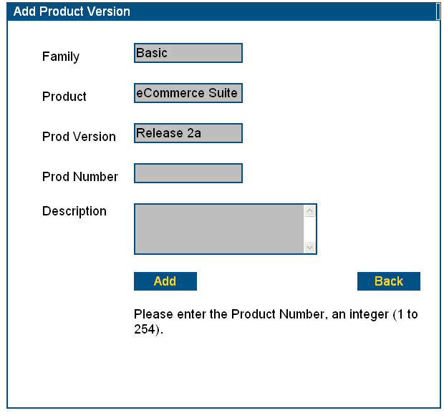
Product Number required.
Product Number required message.
Figure 3-10 Add Product Number message

- Enter the Product Number.
Note: The Product Number refers to the product ID you were given when you received your developer keys for CrypKey Instant or CrypKey SDK.
- If the action was successful, CasperWeb displays the following message:
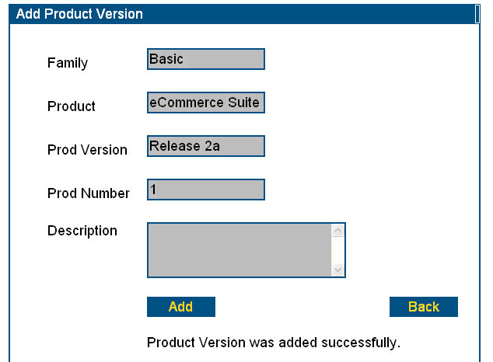
Product Version and Number added
successfully.
Figure 3-11 Add Product Version and Number message

- Click Back to return to the Family and Product screen.
- CasperWeb allows you to add any number of product versions to a single product. Therefore, you may want to add more versions to the product(s) you previously entered.
- Continue adding families and product information until you have added all the products and product categories you wish to store in the Casper database for processing and maintenance.

Modify Product Information
You can modify the description of a product or the product number. To modify product information, follow the steps below.
Note: You can only edit a Family if there is no Product Code yet associated with it.
Procedure – Modify Product Description
In this example, we will modify the description of a product:
- Go to the Family and Product screen (see Add Product on page 76 for navigation instructions).
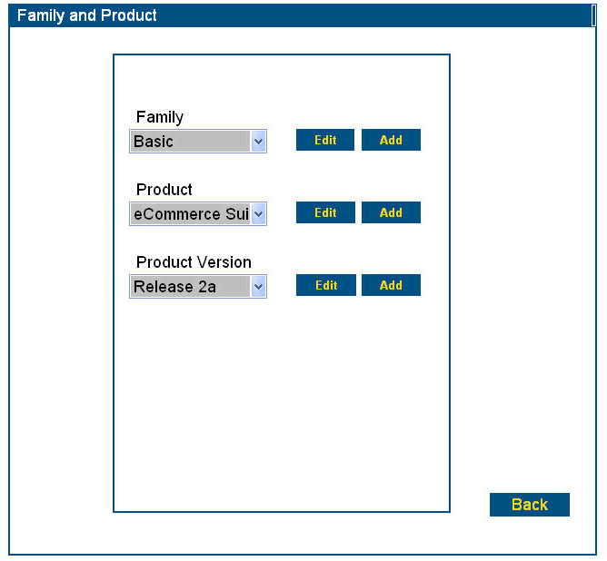
Click Edit beside the product information record you wish to modify. Note you can modify only descriptions and Product Numbers.
Figure 3-12 Edit Product description

- Click Edit beside the Product box. The Edit Product screen displays:
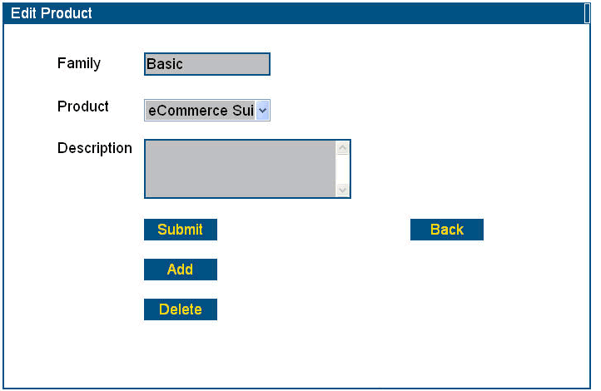
Modify or enter the description.
Click Submit.
Figure 3-13 Edit Product screen
- Modify or enter the description.
- Click Submit. CasperWeb will save the changes in the record, and display a product information update message similar to the following:
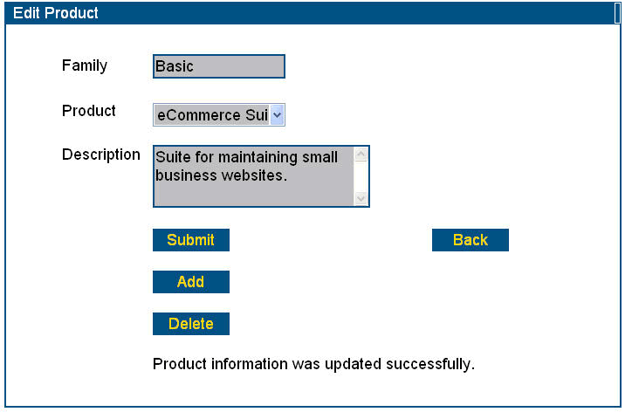
Successful update message.
Figure 3-14 Product description updated message
- Click Back to return to the Family and Product screen.
Procedure – Modify Product Version
- From the Family and Product screen, select the Family.
- Select the Product.
Note: All products for the selected family will be listed in the drop-down menu for the Product, in alphabetical order.
- Select the Product Version to edit.
- Click Edit beside the Product Version field.
- Modify the Product Number or description.
- Click Submit. CasperWeb displays a successful update message similar to the following:
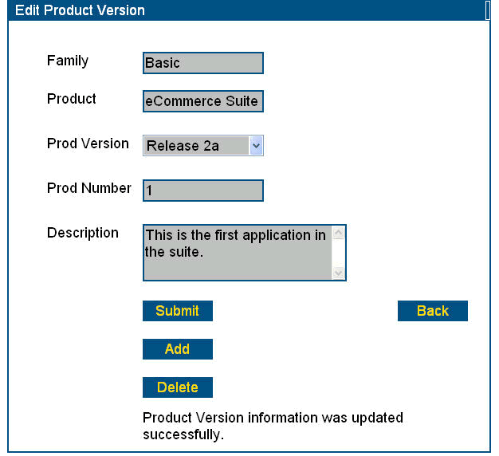
Successful update message.
Figure 3-15 Product Number Description updated
Note: You could have also modified the Product Number in the example above.
- Click Back to return to the Family and Product screen.

Delete Product Information
Use the following method to delete any of the product-related information (Family, Product, Prod Version, Prod Number, Description).
Note: You cannot delete a product record at the Family level without first deleting its child dependencies (i.e. products). If you attempt to do so, you will see the following error message:
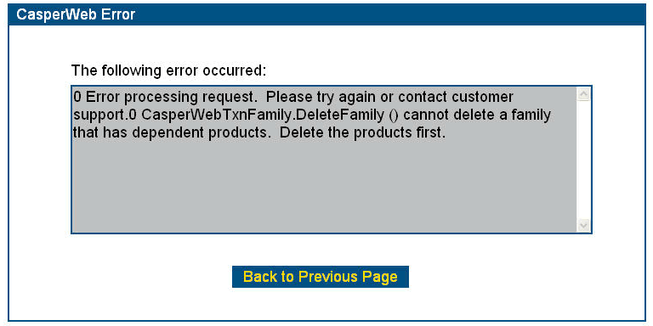
Figure 3-16 Invalid Deletion message
In the example below we will delete a product, “Discontinued”, from the Family “Basic”.
Procedure – Delete Product Information
- Go to the Family and Product screen (see Add Product on page 76 for navigation instructions).
- Select the Family you wish to delete from the drop-down menu in the Family box (in this case, “Basic”).
- Click Edit. The Edit Product screen displays:
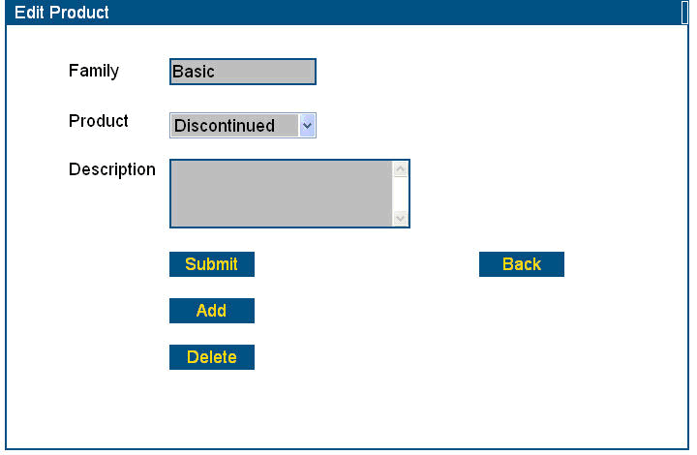
Click Delete.
Figure 3-17 Edit Product screen for deletion
- Click Delete. A message similar to the following displays, asking you to verify the deletion.
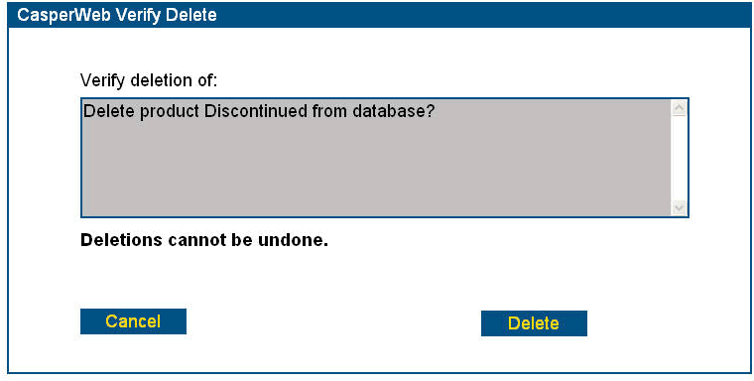
Figure 3-18 Verify deletion dialog box
Note: Deletions cannot be undone. Be sure you want to delete the record before proceeding.
- Click Delete to delete the record, or Cancel to abort the action. If you delete the information, CasperWeb returns to the Edit Product screen. The product will no longer be listed in the drop-down menu beside the Product field.
Note: You can use the above procedure to delete, for example, a Product Version. The version of the product will no longer exist. However, the Product itself will still be intact (unless it is deleted separately).

Set Up Executables, Options and Levels
This section shows you how to add and configure executables, options and levels. This function is accessed via the Product submenu, Executables, Options and Levels option.

Add Executable ID
In order to license a product, you must assign an executable to that product. To do so, use the Add Product Code function (see on page 115). Only one executable can be assigned to a Product Code.
First, you need to set up both an Executable identification (the name of the file) and an Executable Version. Both types of record are required for each Executable.
Procedure – Define an Executable
- Go to the Main menu (see Log on to CasperWeb on page 68).
- Under the Product submenu, click on Executables, Options and Levels. The Executables, Options and Levels screen displays:
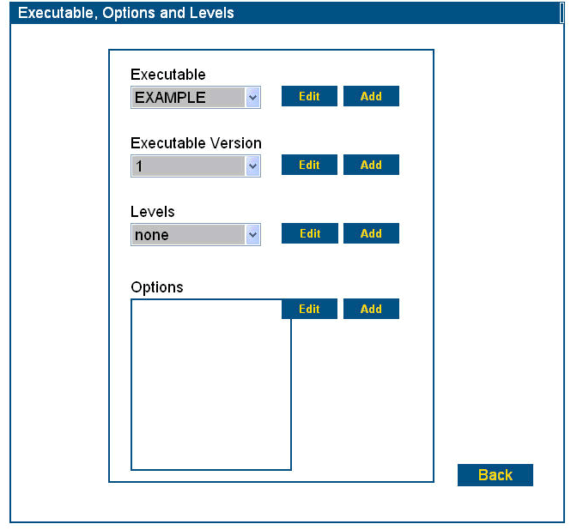
Click drop-down list to see all defined executables.
Figure 3-19 Executables, Options and Levels screen – Add Executables
- The drop-down menu for Executables lists any existing executables in alphabetical order. Select the Executable from the list. Click on Edit to edit an existing executable, or Add to add a new one.
- In this example we will add an executable. Click Add. The Add Executable screen displays:
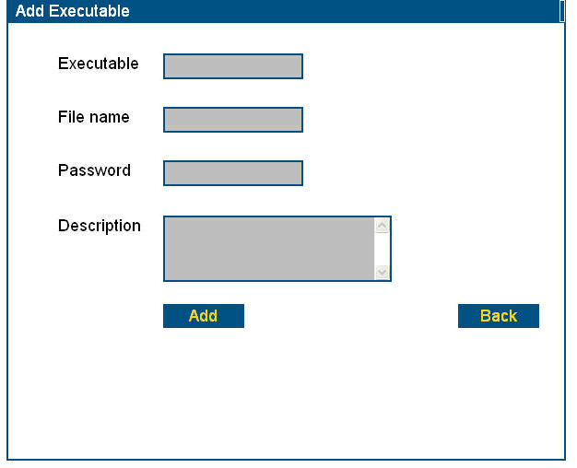
Figure 3-20 Add Executable screen
- Enter the information in the fields as defined in Table 3-1: Executable ID – Data Entry Fields.
Table 3-1: Executable ID – Data Entry Fields
Field | Description
Executable | Name of the executable program. Alphanumeric. Although this can be different from the file name, and does not require a file type extension, we recommend keeping the Executable ID and file name the same.
File name | Name of the executable file as specified to CrypKey when you obtained developer keys for your product. Alphanumeric 8.3 format
Password | Enter the password you gave to CrypKey to obtain your product’s developer keys.
Description | Description of the executable program.
- Enter the name you wish to give to the executable. In the example below it’s “123bbb”.
- Enter the file name of the executable, in this example, “123bbb.exe”.
Note: The file type extension is typically “.exe” but it is not required to be. The filename must be the exactly the same as you gave to CrypKey to obtain your developer keys for this product.
- Enter the executable password.
- Enter a description (optional).
Note: While the Executable name, file name and password are required to create an executable record, the description can be added later if desired; select the Executable from the drop-down menu in the Executables, Options and Levels screen and click Edit.
- Click Add to save the information.
Note: If you try to save the information without entering all of the required information, you will get a message similar to the following (depending on which piece of information is missing: executable name, file name or password):
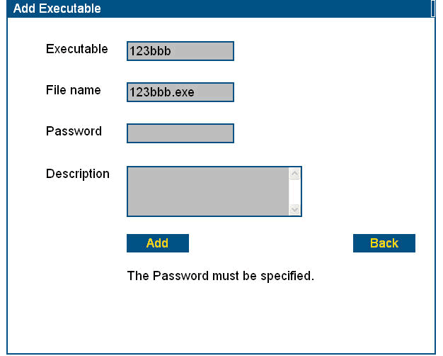
Password is required.
Figure 3-21 Password required message
- If the action is successful, you will see a message similar to the following:
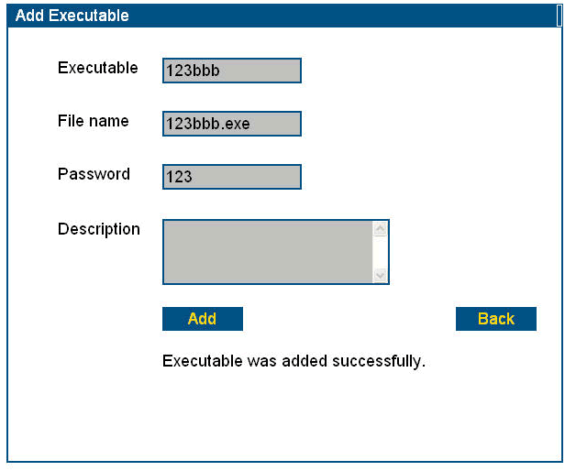
Executable added message.
Figure 3-22 Executable added successfully message

Add Executable Version
As well as being assigned to an Executable, a Product Code must also reference an Executable Version.
Procedure – Define an Executable Version
- Go to the Executables, Options and Levels screen (see the procedure Add Executable ID on page 93).
- The drop-down menu for Executable versions lists any existing executable versions in alphabetical order. Click on Edit to edit an existing version, or Add to add a new one.
- In this example we will add a version. Click Add. The Add Executables Version screen displays:
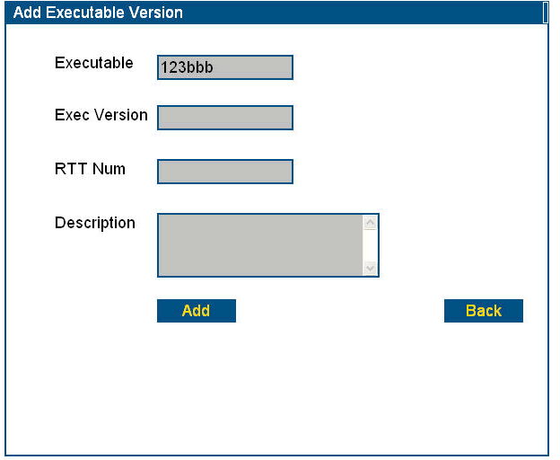
Figure 3-23 Add Executable Version screen
- Enter the Executable Version information in the fields as defined in Table 3-2: Executable Version -- Data Entry Fields.
Table 3-2: Executable Version -- Data Entry Fields
Field | Description
Executable | Name of the executable program. This was previously entered and cannot be changed (other than by deletion and re-entry).
Exec version | Name of the version of the executable. Alphanumeric; max. 13 characters. Samples of valid input: 1, 1.0, one
RTT Num | Currently not used; however you can record CrypKey’s RTT number in this field.
Description | Enter an alphanumeric description of the executable version (optional).
- Enter the Executable Version.
- Enter the description (optional). The description can also be added later by clicking the Edit button opposite the Executable Version field.
- Click Add. You will see a message similar to the following:
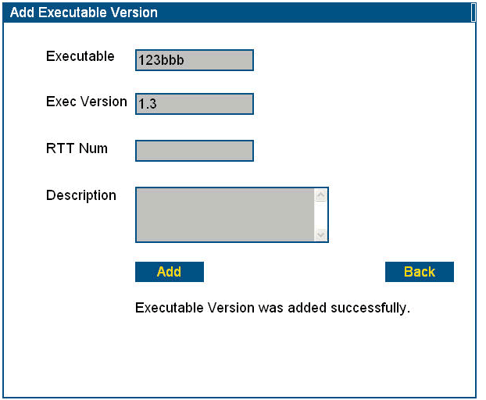
Figure 3-24 Executable Version Added message
- Click Back to return to the Executables, Options and Levels screen.

Add Options and levels
The Product Options and Levels function is used to define or activate features that you want to release with an Executable. Since an Executable record is linked to a product record, options and levels specified for the Executable apply to the product. The license issued to the customer for that Product Code will incorporate the defined Product Codes’ options and levels by default when issuing a license. Options and Levels can be modified at the time of Serial Number creation or Site Key generation.
Options and Levels give you flexibility in defining various features of an application for distribution in packages or specific configurations. You don’t have to use Options and Levels when creating Serial Numbers or issuing Site Keys. However, if you do use them, you must set them up using the Product Options and Levels function before associating them with a Product Code, in a Serial Number record, or in the Site Key Generator.
An Option is a single binary digit — either 0 or 1 — which denotes whether a particular function is available or not. For example, if your product has multiple components and you want your customers to pay per component, you can use Options to specify that only the components ordered by a customer are activated for that customer.
In the Product Options and Levels function, you define the key types of Option information:
- bit position: the placement of the bit in a binary string. For example, the first position in the string might reference a certain report-generating capability of your application.
- the value assigned to each bit position. The value 1 at a given position would mean the Executable is enabled to perform the function defined at that position (e.g., generating certain reports). The value 0 would mean this feature is turned off.
A Level is a number that controls a variety of features in your product. For example, you might define the following levels:
- Level 0: no additional modules can be used
- Level 1: the graphic module can be used
- Level 2: the graphic and printing modules can be used
Levels can also be used for version control. For example, you might decide that the first version (v1.0) of your software runs regardless of level, while v1.1 requires Level 1, v1.2 is not released, v1.3 requires Level 2, and so forth.
Each Executable can have an indefinite number of Levels defined for it. However, for any given transaction (i.e., Customer Information updates or Site Key generation), only one Level can be assigned to an Executable.
When authorizing a product using Casper (automatically) or the Site Key Generator (manually), you must provide a setting (“on” or “off”) for all options defined for the product (i.e., checked = on, unchecked = off).
In order for an Executable to recognize a Level or the Options defined in CasperWeb, the client application needs to implement programming to decode the oplevel value received from the license. If this isn’t implemented, the restrictions that you specify in CasperWeb will not be recognized by the program.
For more details about the mechanisms of options and levels, see Appendix A: Technical References, Internal Handling of Levels and Options.
Procedure – Add a Level
- Go to the Executables, Levels and Options screen (see the procedure Add Executable ID on page 93):
Click drop-down list to see all defined levels.
Click Add.
Figure 3-25 Executables, Options and Levels screen – Add Levels
- The drop-down menu for Levels lists the existing Levels in alphabetical order. Click on Edit to edit an existing level, or Add to add a new one.
- In this example we will add a level. Click Add. The Add Level screen displays:
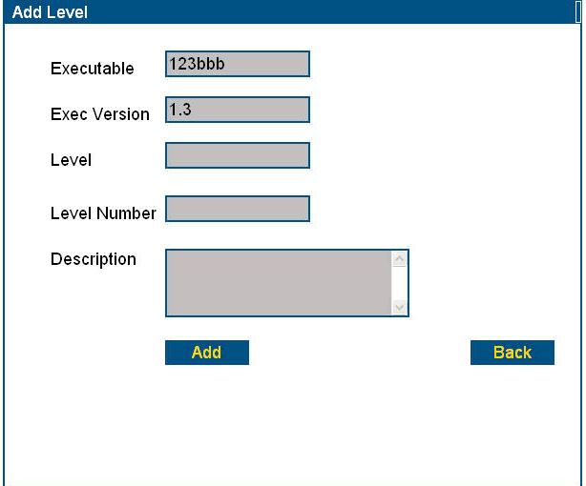
Enter the Level, Level Number and Description(optional).
Click Add.
Figure 3-26 Add Levels screen
- Enter the information as per Table 3-3: Levels -- Data Entry Fields:
Table 3-3: Levels -- Data Entry Fields
Field | Description
Executable | Name of the executable program. This was previously entered and cannot be changed (other than by deletion and re-entry).
Exec version | Name of the version of the executable. This field cannot be edited from this screen.
Level | A number that controls a variety of features in your product, or for version control (see above in this section for more information). Format: alphanumeric (e.g. Regular, Lite1).
Level number | Required with Level. Format: an integer greater than 0.
Description | Enter an alphanumeric description of the level (optional).

- In the Level box, enter the name of the new level.
- In the Level Number box, enter the number of the new level.
Note: Both the level name and number must be entered; otherwise, CasperWeb will display a reminder message.
- Enter the description (optional).
Note: The description can be added later by clicking the Edit button next to the Levels box in the Executables, Options and Levels screen.
- Click Add. If the action was successful, CasperWeb displays a message similar to the following:
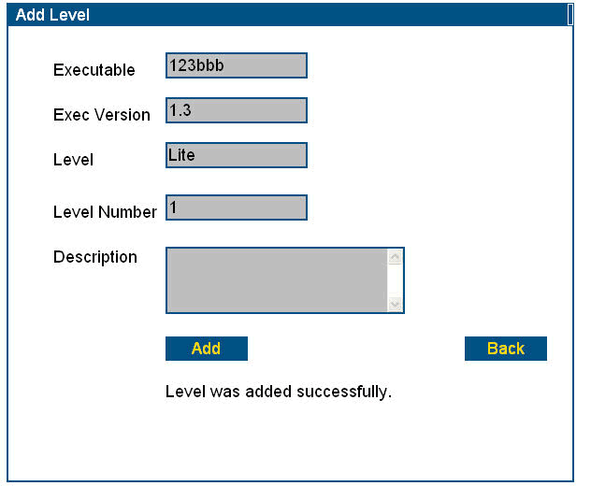
Figure 3-27 Level added message
- A quick way of verifying your additions or changes is to go back to the Executables, Options and Levels screen and display the drop-down list of Levels. Check that your new Level is in the drop-down list of Levels.
Procedure – Add Options
- Go to the Executables, Levels and Options screen (see the procedure Add Executable ID on page 93):
- Select the Executable/Executable Version you want. The Level does not have to be defined. Any existing Options are listed in the Options box on this screen. You define the options here, but not which options will be used.
Click Add.
Select Executable/ Executable Version desired, and Level if defined.
Figure 3-28 Executables, Options and Levels screen – Add Option
- Click on Edit to edit an existing level, or Add to add a new one.
- In this example we will add an option. Click Add. The Add Option screen displays:
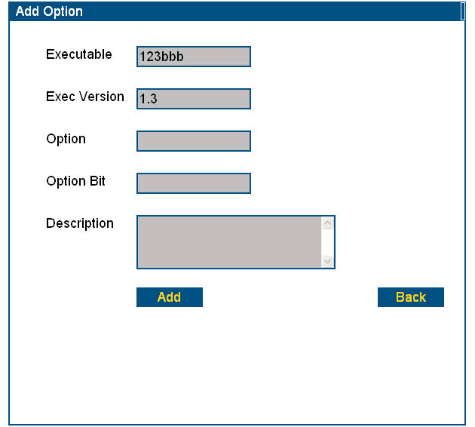
Click Add.
Enter the Option, Option Bit and Description (optional).
Figure 3-29 Add Option screen
- Enter the option information in the fields as defined in Table 3-4: Options – Data Entry Fields:
Table 3-4: Options – Data Entry Fields
Field | Description
Option | Name of the Option associated with the executable; alphanumeric.
Option Bit | Required but not necessarily in use. If it is used, it must have been previously set up in CrypKey SDK or CrypKey Instant or it won’t have any effect in CasperWeb. You must specify the option name and the option bit used for that option.
Description | Enter an alphanumeric description of the Option (optional).
- Enter the Option name.
- Enter the Option bit.
- Enter the Option description (optional).
- Click Add. If the action was successful, CasperWeb displays a message similar to the following:
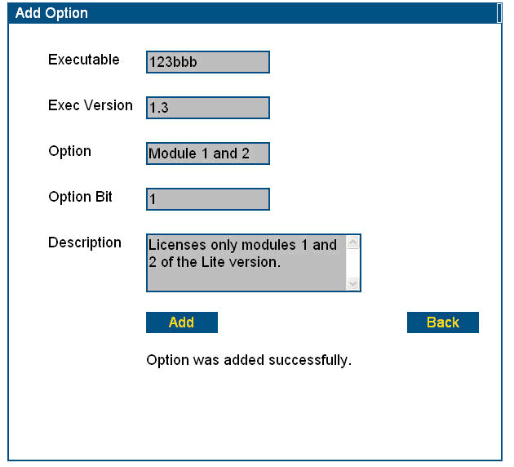
Option added message.
Option, option bit and descrip-tion are added.
Click Add.
Figure 3-30 Option added message
- Click the Back button to return to the Executables, Options and Levels screen. A quick way of verifying your additions or changes is to verify that they appear in the list of Options:
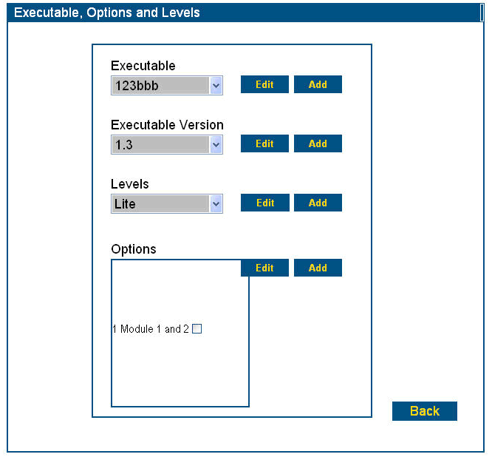
Check that option has been added.
Figure 3-31 New Option is listed

Define License Types
The License Type is a unique three-character value. It’s used by Casper for two purposes:
- to define a default type of product license you could issue. You do not need to specify a license type when using the Product Code Setup Wizard; however, when using the Product Code Browser, you must specify a license type.
- at least one license type must exist in order for you to issue a product license. By default the DEF license type is used with a restriction of three licenses. If you want to use a different license restriction limitation, you can either create a new license type or re-define the restrictions for DEF.

Add a License Type
Procedure:
- From the Main menu, click on the Product menu link, License Type. The License Type screen displays:
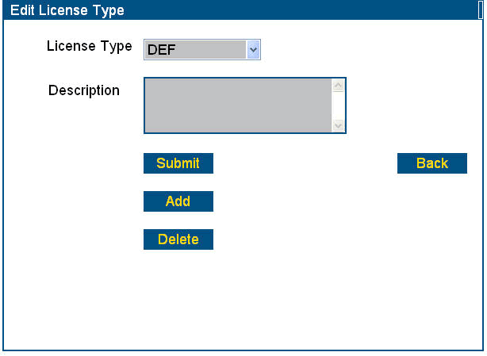
Figure 3-32 Edit License Type screen
- Click on the drop-down arrow beside License Type to see a list of existing license types. DEF is a CrypKey-supplied default. You may use this, edit it, or create your own type of license.
- To add a new License Type, click Add. The Add License Type screen displays.
- Enter an abbreviation or code for this type of license, in the format X3. See the example below:
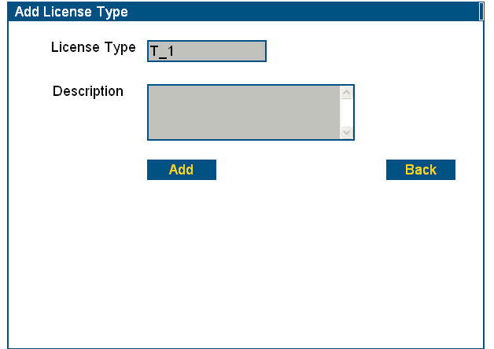
Add the license type.
Click Add.
Figure 3-33 Add License Type screen
- Click Add. You should see a message similar to the following:
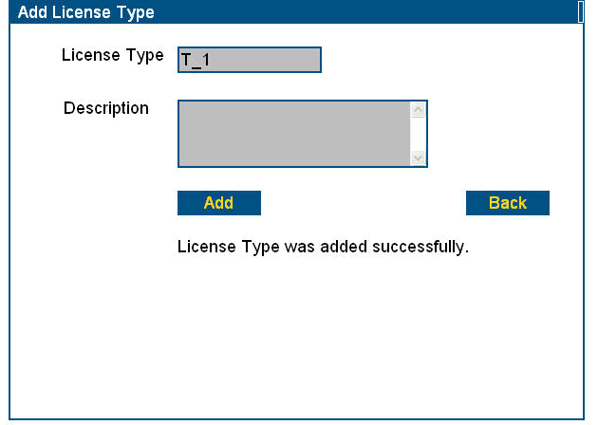
License added message.
Figure 3-34 License Type added message
- Click Back to return to the Edit License Type menu.
- To edit the description, select it from the License Type drop-down list.
- Enter the description.
- Click Submit. You will see a message similar to the following:
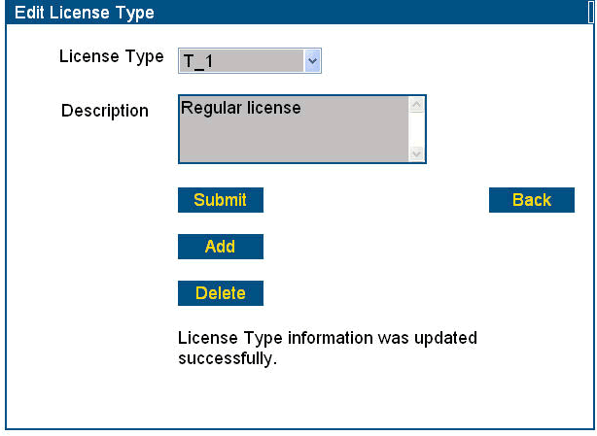
License type updated message.
Figure 3-35 License Type updated successfully message

Add Product Codes
You may add Product Codes using either the Product Code Browser or the Setup Wizard. We recommend beginning with the Setup Wizard, as it is simpler. If you need more than one Product Code for any single application, you must enter the rest of the Product Codes manually using Product Code Browser. You can also modify existing Product Code licensing information through the Browser.
Notes about Product Codes:
- It is necessary to create a minimum of one Product Code for each product.
- Every Serial Number must be associated with a Product Code (see Add Customer Information on page 63).
- A Product Code allows you to associate specific instances of Product Family, Product, Product Version, Executable, Executable Version, and (optionally) License Type, Level, and Options. This information must already be defined in the system before you can create a Product Code; otherwise CasperWeb generates an error message, and you will need to enter the missing items.
Note: Once you have defined a relationship between certain product information using a Product Code, you cannot use the same combination of information with another Product Code.

Product Setup Wizard
The Product Setup Wizard is a quick way to set up the following product details: Executable file name, Password and Product Number.
Procedure – Add Product Codes using the Setup Wizard
- From the Main menu (see Figure 1-1 CasperWeb Main Menu), click on Setup Wizard in the Product submenu. The Product Setup Wizard screen displays, with the defaults. You will replace the defaults with your own data.
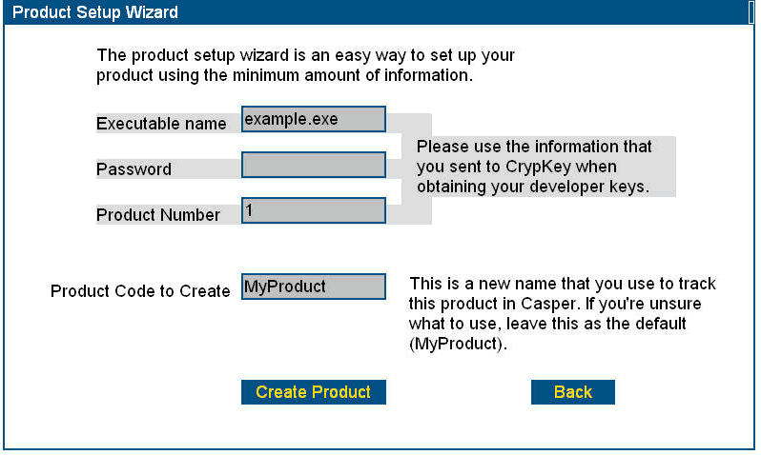
Figure 3-36 Setup Wizard screen – defaults
- Enter the information as shown in Table 3-5: Product Setup Wizard -- Data Entry Fields:
Table 3-5: Product Setup Wizard -- Data Entry Fields
Field | Description
Executable name | Name of the executable program. We recommend using the filename format (8.3) and keeping the executable name the same as the filename. This executable name must be the filename specified to CrypKey when developer keys were generated for the product. If this is not identical the authorization for that Product Code will not work.
Password | Enter the password you gave to CrypKey to obtain your product’s developer keys initially. Alphanumeric.
Product Number | The Product Number refers to the product ID you were given when you received your developer keys for your product. Integer.
Product Code to Create | The Product Code is a unique code. It is used to assign a set of associations among Family, Product Name, License Type, Product Version, Executable Name, Executable Version, Level (optional), and Options (optional) via the Product Code Browser feature. Alphanumeric.

- Enter the executable file name.
Note: This is the name of the file you supplied to CrypKey in order to get your developer keys for your product.
- Enter the password that you provided to CrypKey to obtain your developer keys.
- Enter the product number you were given when you received your developer keys for CrypKey Instant or CrypKey SDK.
Note: Although it’s not shown on this screen, Casper automatically assigns the default license type of “DEF” to the Product Code you’ve created. A license type is required in order to create a Product Code. The default number of runs for DEF is 3. You can change this license type to one you create (see Define License Types on page 112), and then assign a new license type to the Product Code and executable (see Product Code Browser on page 120).
Note: The particular combination of an executable, password, product number and default license type can be used only once. However, the default license type “DEF” can be re-used for other product executables.
- Click Create Product:
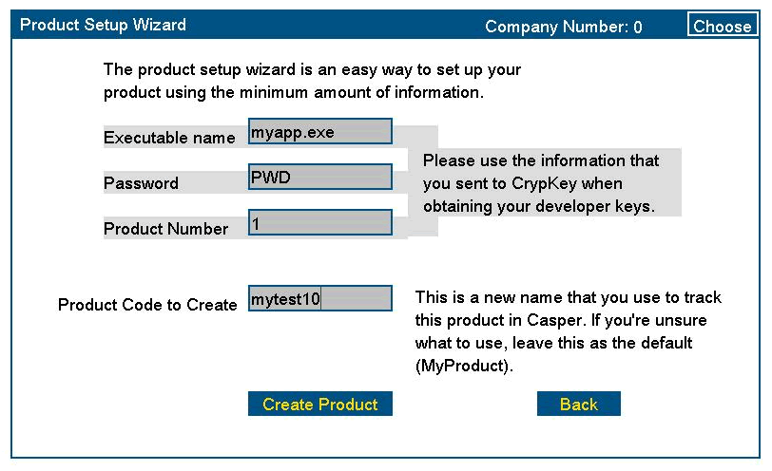
Figure 3-37 Add Product Code using Product Setup Wizard
- You have now associated a Product Code with an executable. You can also do this through the Product Code Browser function (see the following section).
- You can then associate the Product Code (and related executable) with a Family, Product, Product Version and License Type (see on page 115).
- The new Product Code is listed on the Product Code Browser screen:
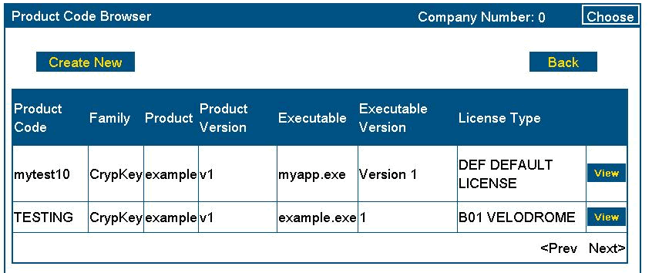
New Product Code added.
Figure 3-38 Product Code Browser listing added Product Code
- When you add a customer (see Add Customer Information on page 129) you will select a Product Code to be associated with a Serial Number. (Every customer is assigned a unique serial number in order to be authorized.)

Product Code Browser
Procedure – Add Product Codes using the Product Code Browser
Note: Before you can create a Product Code through the Browser, you must set up the associated information: Product Family, Product, Product Version, Executable, Executable Version, and License Type. See the applicable sections above.
- Go to the Main menu.
- Under the Product submenu, click Product Code Browser. The Product Code Browser screen displays:
Note: You can create a basic Product Code quickly using the Setup Wizard. See Product Setup Wizard on page 120.
Click
Create New.

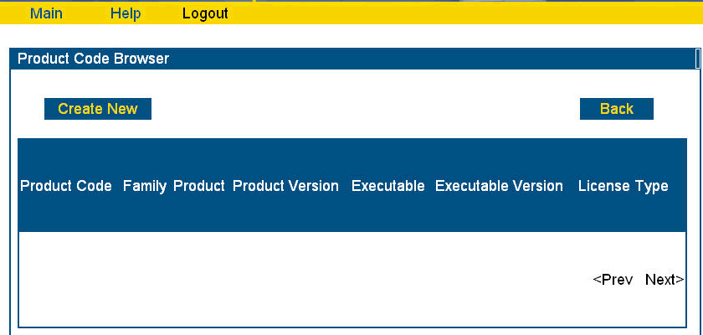
Figure 3-39 Product Code Browser screen
- Click on Create New. Casper displays the following screen:
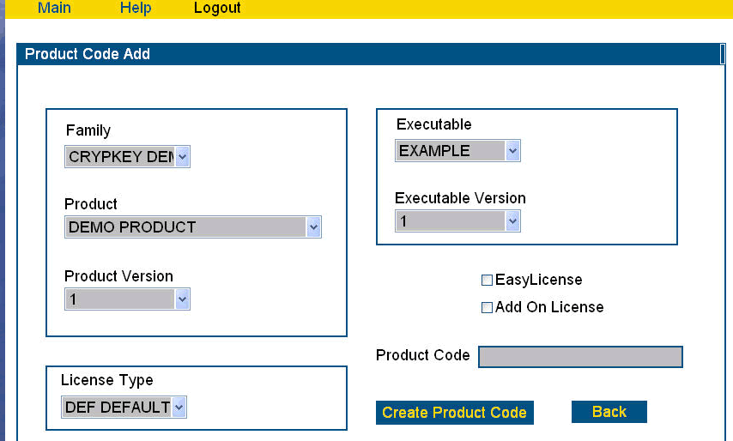
Figure 3-40 Product Code Add screen
- Select one or more of the items you wish to associate with a product. Click the drop-down arrow beside the Family, Product, Product Version, Executable, or License Type. The Executable to be authorized is required, the other fields are optional.
- EasyLicense is used to apply an unlimited license (no restrictions) to a particular computer. This will override any other license type for that product. In order to use EasyLicense, Casper must be able to read a HDSN for the computer (contained in the Site Code). The Customer History screen shows a sample below. EasyLicense is not a license type generally used by Casper, but is available if it meets your company’s needs. Call CrypKey Technical Support if you have any questions about this function.
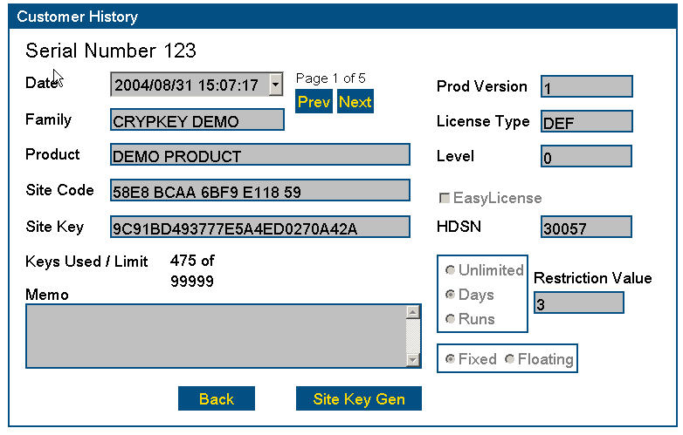
Hard Drive Serial Number.
Default license run restriction.
Figure 3-41 Customer History showing HDSN
- Add On License is defined in the Add Customer Information screen (see Add Customer Information on page 129).
- In the Product Code field, enter the alphanumeric Product Code (which represents the association of this product with the other details you select). The resulting screen will look similar to the example below:

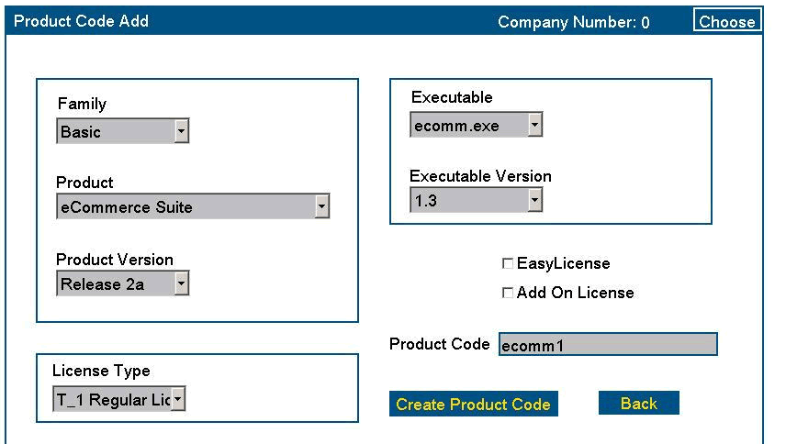
Click
Create Product Code.
Figure 3-42 Add Product Code using Product Code Browser
- Click Create Product Code. You will see a message similar to the following:
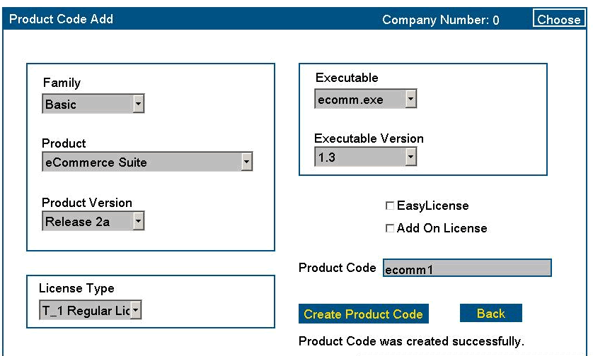
Product Code added message.
Figure 3-43 Product Code added successfully message
- To verify the new product association, click Back to return to the Product Code Browser screen. The Product Code you just added is listed:
New Product Code is listed.
Click View to see details.

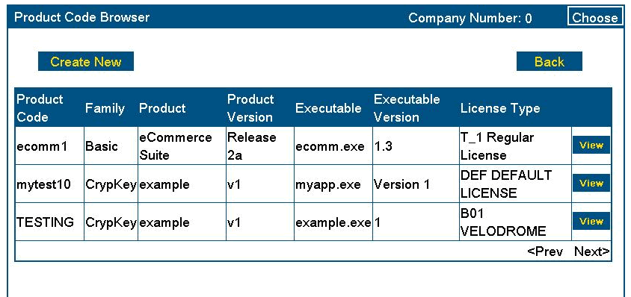
Figure 3-44 Verify Product Code added
Procedure – Browse Product Codes
- To browse Product Codes, go to the Main menu/Product submenu and click on the Product Code Browser link. The Product Code Browser screen displays (see Figure 3-44 Verify Product Code added).
- To view details of any of the listed Product Codes, click on the View button. The Product Code View screen displays:
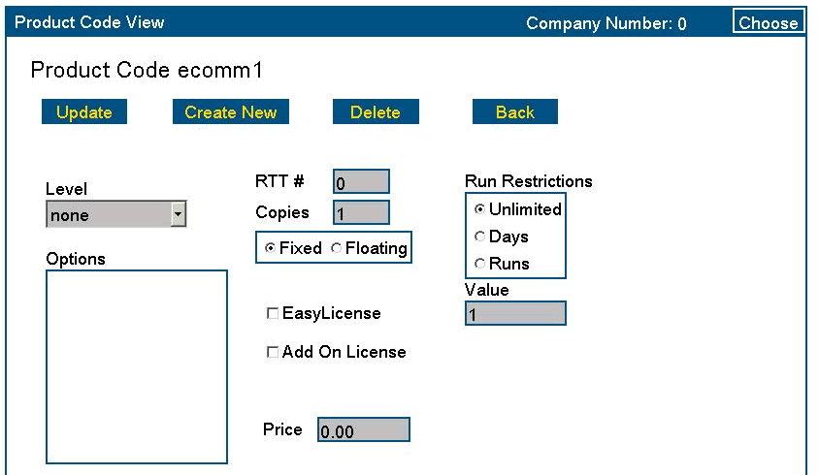
Figure 3-45 Product Code View screen
Procedure – Modify Product Codes
- Note in this view of the Product Code, the Price field appears. This is a required field and can be left at the default value of zero. The price is only applicable if you are using the Casper eCommerce option (see Part 3: Casper eCommerce).
- You can modify the license details as needed. However, remember that the Product Code may be associated with more than one customer Serial Number. Instead of using this screen to make a modification to a Product Code—which will then apply to all Serial Numbers/Customers associated with the Product Code—you may want to change the licensing details for an individual Serial Number. You would do this using the Edit Customer screen (see Edit Customer Information on page 136). The following figure shows the sample Product Code ‘ecomm1’ with a modification (in this example, number of copies has been changed from Fixed to Floating type, and the number increased).
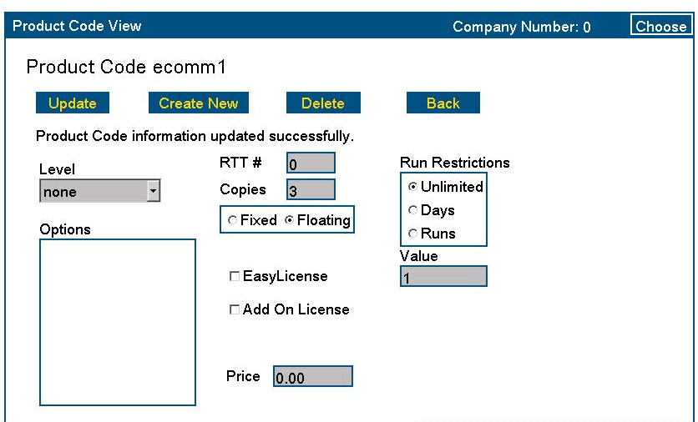
Number of copies modified from 1 fixed to 3 floating.
Figure 3-46 Product Code – modify details
Procedure – Delete Product Codes
- To delete a Product Code, go to the Main Menu and click the link for Product Code Browser under the Product submenu. The Product Code Browser displays. This screen lists any existing Product Codes. If the list extends past a single page, use the Next and Prev buttons to view multiple pages.
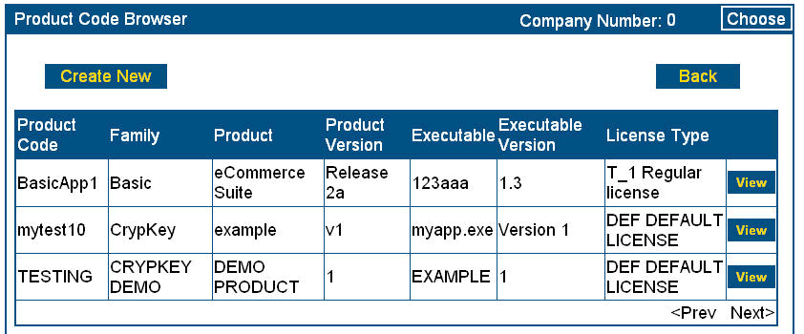
Click View for Product Code you want to delete.
Figure 3-47 Select Product Code to delete
- Click the View button for the Product Code you wish to delete. The Product View screen displays:
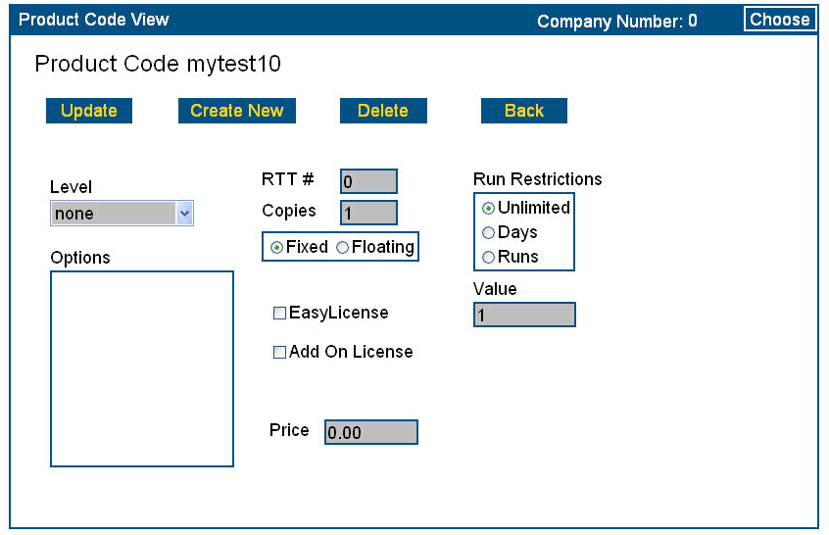
Click Delete.
Figure 3-48 View Product Code to delete
- Click Delete. The following message pops up:
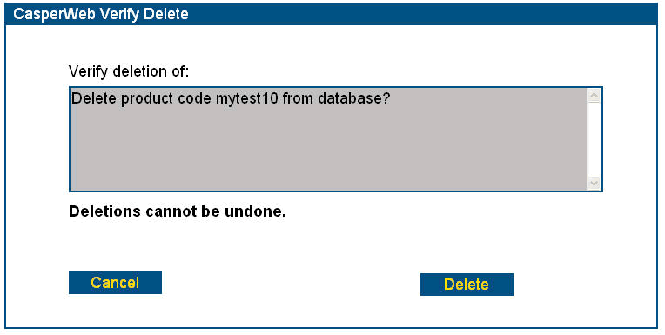
Click
Delete again.
Figure 3-49 Verify Product Code deletion
- Click Delete again to complete the deletion, or Cancel to abort the action.
Note: Deletions cannot be undone. Deletions are not possible if any Serial Numbers are already associated with the Product Code you wish to delete.
- CasperWeb returns you to the Product Code Browser list, where you can verify the Product Code has been deleted:
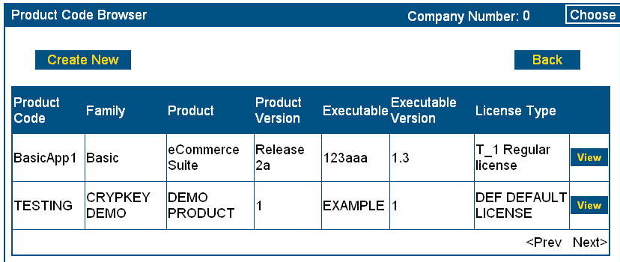
Figure 3-50 Product Code list with deletion

Chapter 4: Managing Customers
CasperWeb offers an easy interface for managing customer information.
Once you have created one or more Product Families, Products, Product Versions, and the associated Executable information, you can add customers to the Casper database. Use the Add New Customer option in the Main menu to create customer records. When you add a customer, you will select a Product Code to be associated with a Serial Number. (Every customer is assigned a unique Serial Number in order to be authorized.)
From the Add New Customer screen you can generate Site Keys for customers as you input customer information (see Generate Site Keys on page 142). However, you would normally use this feature only if a customer has submitted an authorization request over the telephone or by regular email. If the customer uses the CrypKey Instant interface to transmit the request including Site Code, your Casper Server should automatically generate and send out the Site Key.
Note: When creating Customer records, the critical information to enter is the Serial Number and Product Code. The other information–such as name, address, product, and license details–can be entered later as updates using the Edit Customer Info option, or it can be left blank for the customer to enter at the authorization stage.

Add Customer Information
Use this function as a way to add new customers to the database. You can also add customers to the database using the import function.
Procedure
- From the Main Menu, Customer Info submenu, click on Add New Customer. CasperWeb displays the Add New Customer screen:
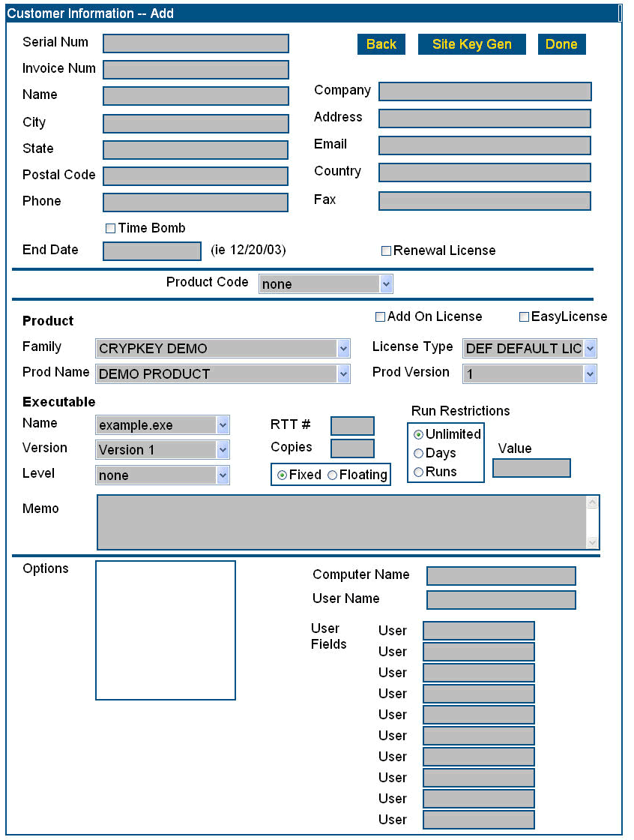
Figure 4-1 Add Customer screen
- Scroll down to see the entire contents of the window.
- Enter the data or make selections as per Table 4-1: Customer Information—Data Entry Fields.
Note: The only required fields are Serial Num and Product Code. There is no other information needed. The rest of the customer information may be added if desired using the Import function in the System Maintenance menu (see Chapter 5: Managing CasperWeb, Auto Import on page 165).

Table 4-1: Customer Information—Data Entry Fields
Field Name | Description
Serial Num | Customer’s Serial Number. Required field used as the key to all customer information. Format: free-form.
Invoice Num | The number of your invoice to the customer.
Name | Customer name.
City | City in which the customer resides.
State | State or province in which the customer resides.
Postal Code | Customer’s postal code.
Phone | Customer’s telephone number.
Time Bomb | Checkbox indicating whether CasperWeb will calculate the number of days remaining until the expiry date specified in End Date (see below). The calculated value is incorporated into the license.
End Date | Expiry date of license.  Format: mm/dd/yy.
Company | Customer’s company name.
Address | Customer’s company address.
Email | Customer’s email address.
Country | Country in which the customer resides.
Fax | Customer’s corporate fax number.
Renewal License | Checkbox indicating whether the current transaction will renew the customer’s existing license until the specified expiry date.
Keys Used/Limit | Number of Site Keys that can be generated for this Serial Number, and maximum allowable number of Site Keys generated for this Serial Number.  Note: This field appears in the Customer Information screen (see Figure 4-4 Customer Serial Number search), but not in the Add Customer screen.
Middle portion of window – Product section

Product Code | Product code created in the previous section which defines a license type for the product being authorized for this specific serial number. The code references a set of associations among Family, Product Name, License Type (optional), Product Version, Executable Name, Executable Version, Level (optional), and Options (optional).
Add on License | Checkbox indicating whether the current transaction will add to the existing license of the product. An add-on license operates as an addition to the original, which remains in effect. Check the box and select the additional days, runs or options you want to enable. Note this can also be changed through the Product Code Add screen.
EasyLicense | Enables an unlimited license for a particular computer. This type of license will only work if the Site Code that comes in to Casper for the specific Serial Number has a valid HDSN. If no HDSN is available the user will not receive a license.
Family | Product family
Prod Name | Product Name
License Type | A 3-character abbreviation defined by you, the software vendor.
Prod Version | Product Version
License type | Type of product license
Middle portion of window – Executable section
Name | Executable name
Version | Executable version
Level | Level
RTT # | Ready-To-Try number. Feature currently not used in CasperWeb but can be used to record the number.
Copies | The number of copies of the software that you would like the customer to be issued access to with one authorization.
Fixed/Floating | Fixed means running the software on standalone computers. Floating means the ability to run x number of seats concurrently over a network. Both fixed and floating can be issued more than one copy.
Run Restrictions | Radio buttons indicating whether the license can be run indefinitely (unlimited) or for a specified number (see Value, below) of days or runs.
Value | Number denoting days or runs, as selected in Run Restrictions.
Memo | Any notes that you would like to add for this specific serial number.
Lower portion of window – Options section | If Options have been defined for the Product Code, you can select the options for this specific Serial Number.
Computer Name | Specifies the computer name of the user requesting authorization.
User Name | Specifies the username once authorized if configured in Casper Wizard.
User Fields | Ten supplemental data fields (User1, User2, etc.) used to accommodate information values not included in the standard CasperWeb customer record. For example, the standard CasperWeb customer record includes the customer name, but you may want to record another technical contact name and phone number. You could use the User Fields feature to record this information. We recommend that in each field you use, you put consistent types of information (User1, User2, etc.). In this way, you will maintain consistency of record content.

- The following figure shows a sample of adding a customer:
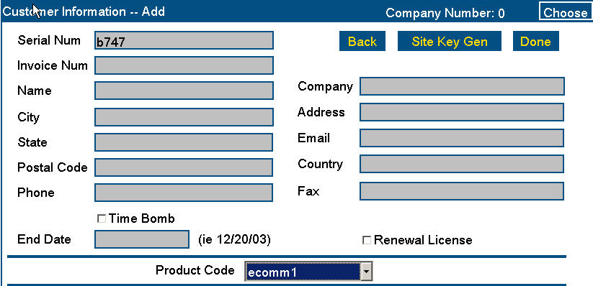
Figure 4-2 Customer added
- When you are satisfied with the entry, click Done. CasperWeb displays a message similar to the following:
Customer added message.
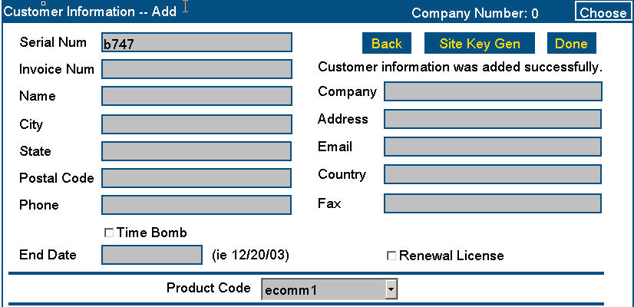
Figure 4-3 Customer added successfully message
Note: You may encounter problems if you:
  - Click the Renewal License checkbox when using a Product Code for an add-on license.

Edit Customer Information
Use this function to review and revise customer information: for example, you want to add more data to the new customer in the example above.
You can modify the Customer name and other data in the record, but not the Serial Number itself.
Procedure
- From the Main Menu, Customer Info submenu, click on Edit Customer Info. CasperWeb displays the Customer Information screen.
- To search for a customer record, enter the serial, name or invoice number in the Find box and click the button of the same type (Serial, Name, Invoice). See the example below.
Note: Search conventions are:
- You can type the full value, a partial value together with the wild card “*”, the full value including the placeholder “?”, or “*” by itself, as in the following examples:
  - Full value – for example, if you type in 123 and click Number, CasperWeb will search for a match strictly based on the Serial Number 123.
  - Partial value plus wild card – for example, if you type in 100* , CasperWeb will match to all Serial Numbers beginning with 100, such as 10010 and 10044.
  - Full value including the placeholder “?” character – for example, 100?5 will match the Serial Numbers 10015 and 10025, but not the Serial Numbers 10016 or 1001599.
Enter serial number and click
Serial button.

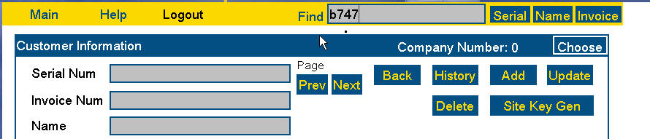
Figure 4-4 Customer Serial Number search
- CasperWeb will display the first value in the list of results. If there is more than one result, you can click on the drop-down arrow in the box for the searched field (Serial, Name, Invoice). See the following example:

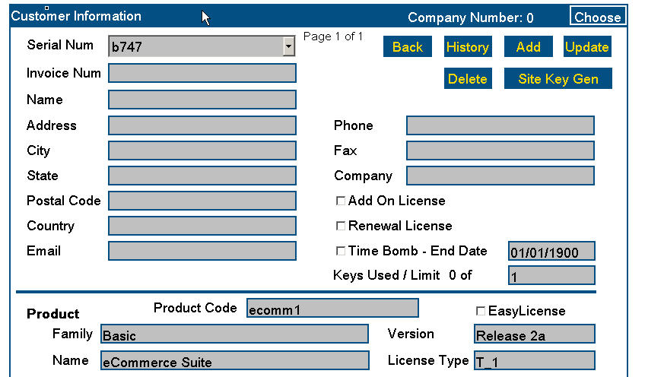
Figure 4-5 Serial Number search results
Notes
- The Serial Number—not the customer name—is the key field used by CasperWeb to reference customer records.
- The Serial number is associated with a Product Code, so the Product Code information will be displayed in the middle portion of the window as well as the customer information.
- In typical searches, more than one piece of information will often be found. When this happens, CasperWeb displays all found matches in a drop-down list beside the data field searched – i.e., beside the Serial Num, Invoice Num, or Name field as applicable. If the search generates too many matches to fit into the drop-down list box. you can use the Prev and Next buttons to display other additional matches.
- The Product and Executable fields in the middle portion of the window (see Figure 4-2 Customer ) are not editable, since they directly reference Product Code information.
- The User fields in the lower area of the screen are typically customer inputs from the Casper wizard. If you require your customer to input User information in the Casper Wizard, it will overwrite whatever you may enter in these fields. If you have notes you want to enter, use the Memo area (see Figure 4-1 Add Customer screen).
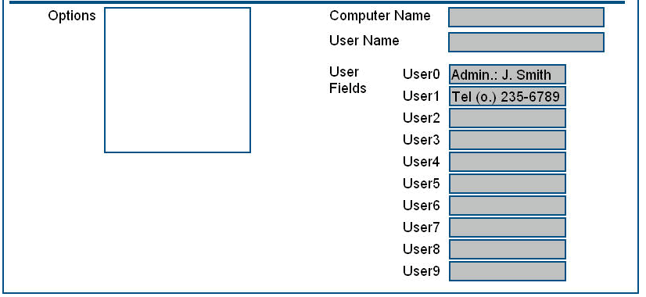
Figure 4-6 Edit Customer screen—User fields
- When you have found the record you want to modify, type values into the fields, then click Update. CasperWeb will save the changes you have made, and display the Customer Information window as in the example below:
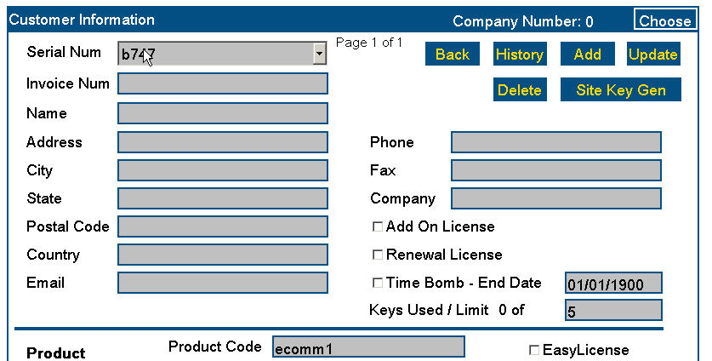
Enter edits and click Update.
Sample edit: license limit increased from 1 to 5.
Figure 4-7 Edited Customer Information

Delete Customer Information
Procedure
- Follow the instructions above in Edit Customer Information to find the record you want to delete.
To delete a record, Find it and then click Delete.
Figure 4-8 Find Customer record to delete
- Click the Delete button to delete the record. CasperWeb displays a deletion verification message:
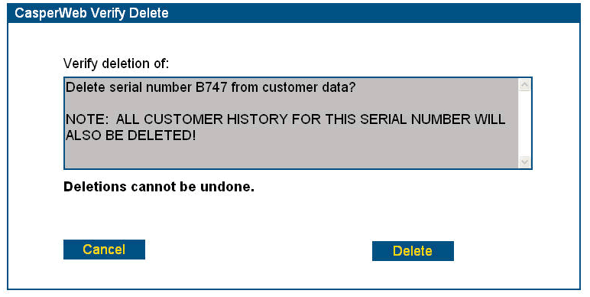
Click Delete to delete record; Cancel to cancel action.
Figure 4-9 Verify Customer record deletion
Note: Deletions cannot be undone.
- CasperWeb will display a message similar to the following:
Customer Record was deleted.
- Or, click Cancel to cancel the action. Deleted records cannot be reversed.

Display Customer History
The Customer History feature, launched using the History button in the Customer Information window, displays the Site Code and Site Key history for the selected Customer record. The key data value in this function is the Serial Number (not the customer name). The customer history screen has records of all Site Key Generations.
The Customer Information history contains authorization details, by customer, of specific products (including executables and version numbers) and restrictions you impose on customers’ access to the purchased products.
When Casper generates a Site Key, CasperWeb records several items, including the Serial Number, the date, the product Family and product name, the Site Code provided by the customer, and the generated Site Key. Each generation of a Site Key results in a set of these values being recorded in the system. The History function makes this information available for display.
Procedure
- From the Main Menu, Customer Info submenu, click the Edit Customer Info link. CasperWeb displays the Customer Information screen (see Figure 4-12 Site Key Generator screen).
- To search for a customer record, enter the Serial Number, name or invoice number in the Find box and click the button of the same type (Serial, Name, Invoice). In the example below, we use Serial Number b747.

Figure 4-10 Customer Information screen
- In the Customer Information screen, click History. CasperWeb will display the following screen:
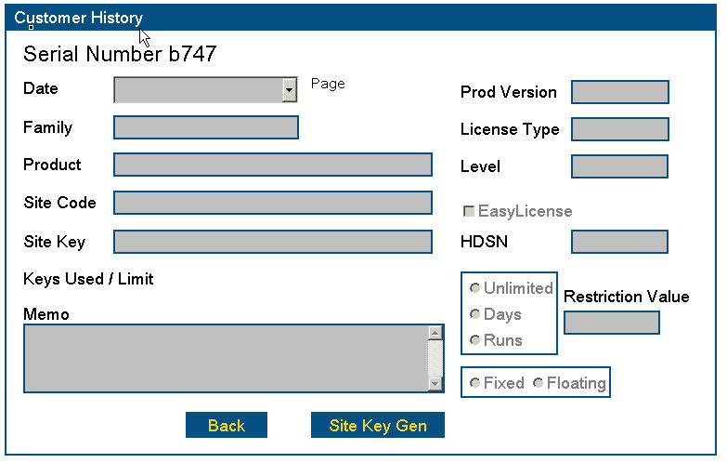
Click Date arrow to see list of dated transactions for the Serial Number.
Figure 4-11 Customer History for specified Serial Number
Note: The Memo field will be blank unless the Casper Site Key Generator was used to manually generate a Site Key and a memo was entered at that time.
Note: The fields in the sample Customer History screen above will be filled in if there has been an authorization for the Serial Number.
If more than one authorization has been recorded for the specified Serial Number, you will be able to display a drop-down list of authorization dates in the Date field. The screen will show the Site Codes, Site Keys and other information related to each dated authorization.

Generate Site Keys
The Site Key Generator enables you to manually create and send Site Keys to your customers, authorizing them to use your software. Normally the Site Key is generated automatically over the Internet using Casper, but there may be cases where the customer hasn’t been able to send you a request for a license using the Casper Client Wizard (which you bundled with your software). You could also use the manual Site Key Generator that came with CrypKey Instant or SDK.
A Site Key is a character string that is output from the processing of a Site Code received with your customer’s authorization request. The Site Key also incorporates restrictions that you specify for the user license. The Site Code is generated by CrypKey, based on information extracted from the customer’s computer.
Note: You would normally use the Site Key Generator only if a customer has submitted an authorization request over the telephone or by regular email. Normally the customer uses the Casper Electronic Purchase Wizard to transmit the request, including the Site Code, and your Casper Server should generate and send out the Site Key automatically.
To generate a Site Key using the Site Key Generator in CasperWeb, you manually enter the Site Code, along with restrictions for your customer’s software use, into input fields in the Site Key Generator screen. The Site Key Generator creates a Site Key from this information, which you send to your customer by email, telephone, or fax.
You can launch the CasperWeb Site Key Generator from two places:
- the Customer Information – Add window, after you have created a record; or
- the Customer Information screen (accessed from the Edit Customer option on the Customer Info menu).
Procedure
- Do either of the following:
- click the Done button to complete the addition of a new record (see Add Customer Information on page 129).
- display the Edit Customer window for a specific record (see Edit Customer Information on page 136).
- Click the Site Key Generator button. CasperWeb will display the Site Key Generator screen for the selected Serial Number:
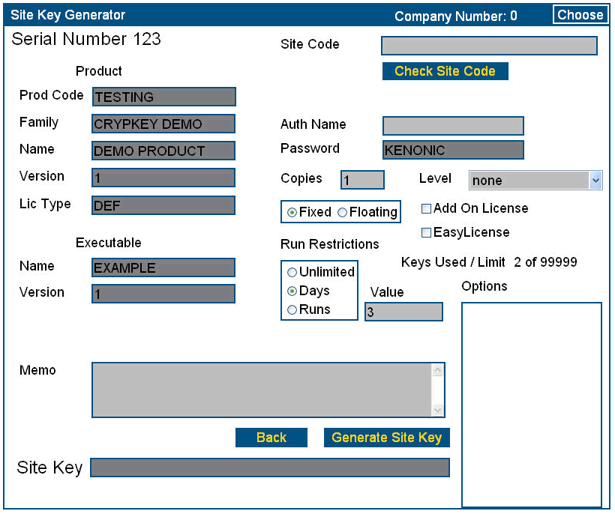
Enter the Site Code, then click Check Site Code.
Figure 4-12 Site Key Generator screen
Notes:
- The Serial Number appears in the top left-hand side of the screen. For descriptions of the fields see Table 4-2: Site Key Generator —Data Entry Fields.
- The Keys Used/Limit field contains the number of Site Keys previously generated for this Serial Number, and the maximum number as defined in the Customer Information record.
- Shaded textboxes are automatically populated by the Site Key Generator, and are not editable.
- In the Site Code field, type in the Site Code received from your customer.
- Click the Check Site Code button. If the test is successful, you will see a message similar to the following:
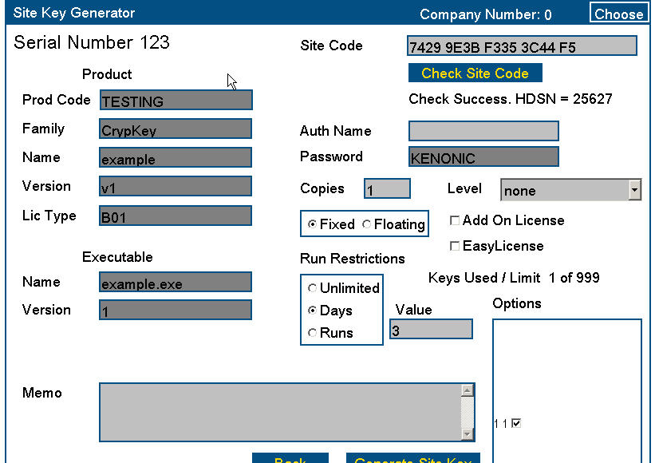
Site Code check successful message.
Figure 4-13 Check Site Code test message
- Select the criteria you want applied to the license, such as number of copies, level, options, and run restrictions. Optionally, type a name into the Auth(orization) Name field, and a note into the Memo field (for the Vendor’s use).
- When you are satisfied with your data input, click Generate Site Key. The screen now appears as follows (note the Site Key field is filled in):
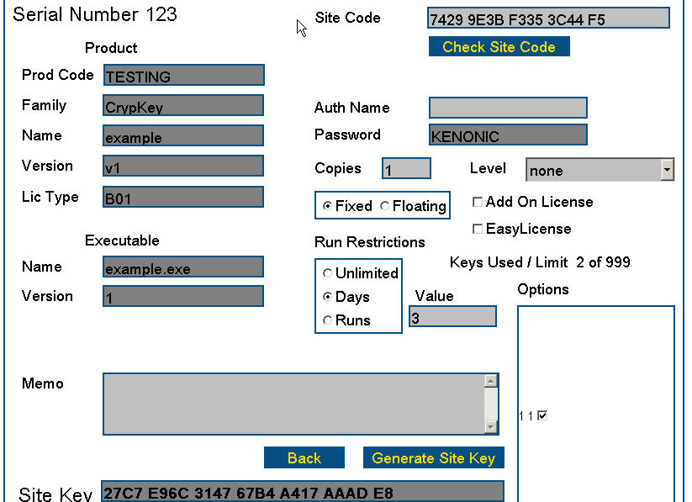
Site Key has been generated.
Figure 4-14 Manually generated Site Key
- Copy the Site Key from the above window into a regular email to be sent to your customer.
Table 4-2: Site Key Generator —Data Entry Fields
Field | Description
Non-Editable Fields
Product
Serial Number | A Serial Number is tied directly to a Product Code for a specific customer. (see Customer Information screens in the section above, Add Customer Information).
Prod Code | Product Code which the Serial Number is associated with.
Family | Product family, defined in the Product Family records in CasperWeb.
Name | Product name.
Product Version (number) | Product version number — this is the version number set for this Product Code.
Lic Type | License type is directly associated with Product Code, it is defined when the Product Code is created.
Executable
Name | Filename specified in the Product Code creation. This is the filename that you used the obtain developer keys from CrypKey.
Executable Version | Executable version number — the source is the Rev. No. value defined in the Product Code creation process.
Memo | Optional free-form field for entry of instructions or other information concerning the generated Site Key.
Password | Password defined for the Executable in question (see Figure 3-23 Add Executable Version screen).
Editable Fields
Site Key Generation
Site Code | Site code is the string of characters created by the client side software to obtain authorization. This information is not seen by the user if they do their authorization via http. If the customer does not have access to e-mail or http they can call and give you the Site Code.
Auth Name | Name of the user you are generating a Site Key for. Format: X13.
Copies | For fixed licenses: the number of copies of software you would like the user to be able to run on different machines at one time. If you issue 3 copies, the customer has the ability if enabled in your software to transfer the software to two other machines and still have a copy available on their own machine. Format: I9  For floating licenses: the number of users who can concurrently use the software over a network. Format: I9.
Fixed button | Option button: fixed type of license (i.e., the software must be run on one or more specific computers, depending on the value specified for Copies (see above).
Floating button | Option button: floating type of license (i.e., the software is loaded on a Server and can be accessed concurrently by one or more users, depending on the value specified for Copies (see above).
Level | Level assigned to the license (default value: zero (0)). A level is a number that controls a variety of features in your product. A corresponding number must exist in the actual software.
Add-on License checkbox | Checkbox used to indicate the license will add to an existing authorized license.
Keys Used/Limit 0 of 1 | This dual field contains:  - The number of authorizations already generated for this Serial Number;  - The maximum allowable number of authorizations that can be generated for this Serial Number (as defined in the Customer Information screen, see Edit Customer Information on page 136).
Run Restrictions | Any of the following restrictions on the customer’s use of the program:  - unlimited (no restrictions applied)  - days (the number of days the customer can run the program)  - runs (the number of program runs available to the customer)  If Days or Runs is selected, you must input the number of days or runs into the Value field on the right of the panel.
Value | Number applying to the selected Run Restrictions.
Options | Checkboxes representing options (defined in the Options and Levels function – see101101) that you can select or deselect.

Chapter 5: Managing CasperWeb
CasperWeb offers an easy interface for user and system maintenance tasks.
C

asperWeb is the Graphical User Interface (GUI) you use to manage your customer and product information in the Casper database, and to maintain the system. See Chapter 1: Overview for more information.
System maintenance and user functions are available in CasperWeb from the Main menu, SuperUser submenu. See Figure 5-1 SuperUser menu:
Access system and user maintenance from the SuperUser menu.
Figure 5-1 SuperUser menu
Note: The SuperUser menu is available only to those with SuperUser access, i.e. administrators.
Note: CrypKey eTransfer maintenance is also available from the SuperUser menu. This feature is discussed in Part 5: Casper eTransfer.

User Maintenance
The person(s) in charge of administering your CasperWeb installation can add, modify, and delete users with varying levels of access privileges, as well as change passwords. CasperWeb administrators must have “Super User” access privileges.

Add a User
Procedure
- Go to the Main menu (see Log on to CasperWeb starting on page 68).
- From the SuperUser menu, click the User Maintenance link. The User Maintenance screen displays:
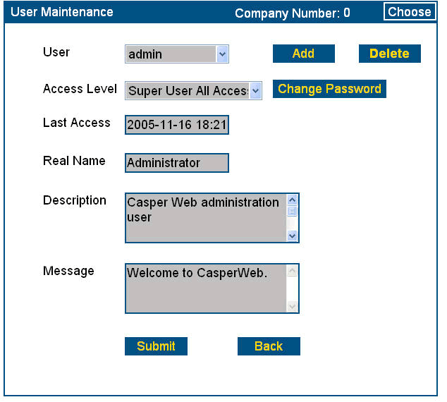
Click Add.
Figure 5-2 User Maintenance screen
- Click Add. The Add New User displays:
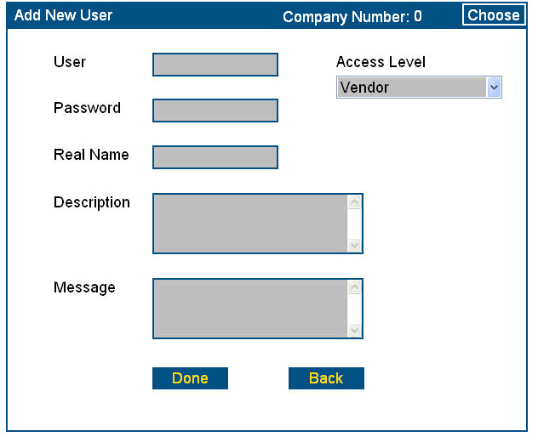
Select from pre-determined access level.
Enter the other information.
Figure 5-3 Add New User screen
- Click on the drop-down arrow for the Access Level field to select an access level, which is pre-defined in the Casper installation.
- Enter the information as per the following table:
Table 5-1: Add New User — Data Entry Fields
Field | Description
User | User ID
Access Level | Drop-down list containing available access levels (pre-defined)
Password | Password that the user will enter to proceed with the application
Real Name | User’s full name
Description | Relevant information about the user’s role in using the application
Message | Message that the user will see when logging onto the system.
- Click Done. A message will appear on the bottom of the screen to report that you have successfully created a new User.
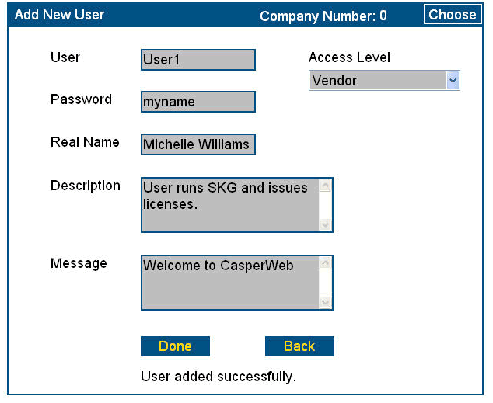
User added message.
Figure 5-4 New User added successfully message
- Click Back to return to the User Maintenance screen.

Delete a User
Procedure
- From the User Maintenance screen (see Figure 5-2 User Maintenance screen), click on the User down arrow to select the User record you wish to delete.
- Click Delete. The Delete button will change to Confirm Delete.
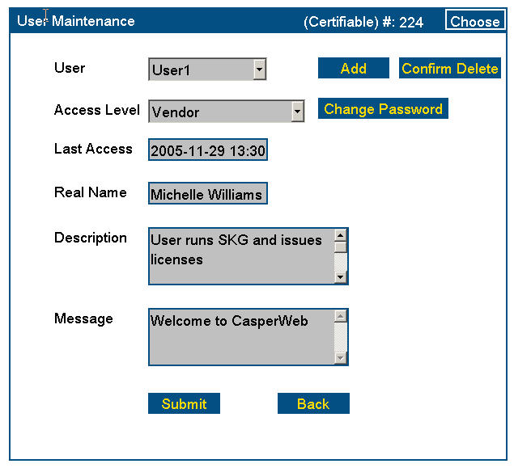
Click to confirm deletion.
Figure 5-5 Delete User confirmation
- If you wish to continue, click Confirm Delete. CasperWeb displays the deleted record:
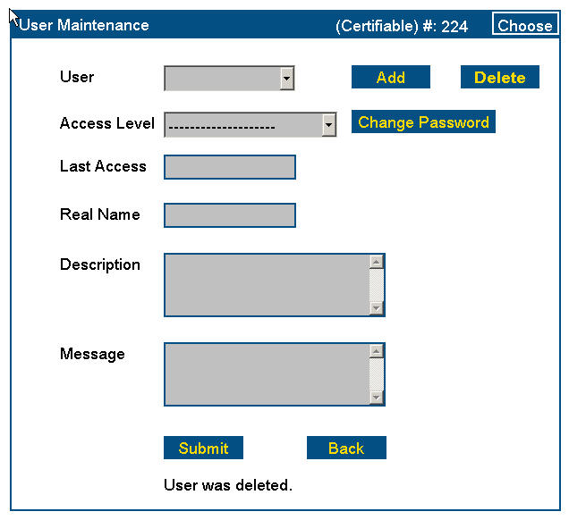
User successfully deleted message.
Select user.
Figure 5-6 User Deleted message

Change a User Password from SuperUser Menu
Procedure
- To change a User’s password from the User Maintenance screen, select the User from the drop-down list.
- Click Change Password. The Change Password screen displays:
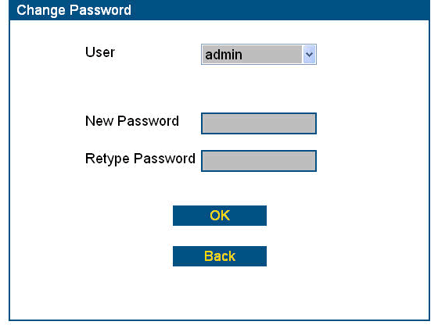
Enter password, and re-enter to confirm.
Click OK.
Figure 5-7 Change Password – from User Maintenance screen
- Enter the user’s new password.
- Retype the password.
- Click OK. You will get a confirmation message that the password was successfully changed.

System Maintenance
Use the System Maintenance menu to view and configure the Casper Server. The System Maintenance menu consists of 9 pages:
- General
- Email
- E-Receipt
- Licensing via Email
- Easy License
- Auto Import
- Credit Card
- Fraud
- Taxes
Note: Pages 1-2 and 4-6 are described in this section; for page 3, and 7-9, please refer to Part 3: Casper eCommerce.

General
Page 1 allows you to configure email settings, database and CasperWeb log in information.
Procedure
- Go to the Main menu (see Log on to CasperWeb starting on page 68).
- From the SuperUser menu, click the System Maintenance link. The System Maintenance screen displays:

Select another menu option, or click Next Page to go page 2.
Enter subject to trigger email processing.
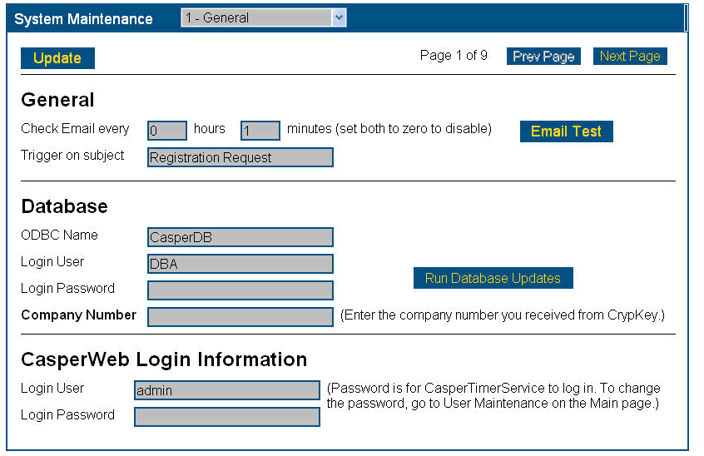
Set timeframe for Casper to check customer emails.
Click to test email checking.
Run database updates.
Enter CasperWeb login information.
Figure 5-8 System Maintenance – General

- Page #1, General, is shown in the drop-down list. To select another option from the System Maintenance menu, click on the drop-down arrow, or click Next Page. Click Prev Page to return to the previous page.
- The General page is divided into three sections: General, Database, and CasperWeb Login Information.
- General area: Enter information as per the following table.

sTable 5-2: System Maintenance/General Page/General – Data Entry fields
Field | Description
Check Email every | How often (in hours and minutes) you want Casper to check for email from your customers. The Casper Client sends email registration requests to the server whenever an HTTP request is unable to be processed. On page 2 of the System Maintenance screen you will set up the email account to be used for this purpose.
Trigger on subject | Acts as a filter for messages. Only emails with the specified subject in the subject line (e.g. “Registration Request”) will be processed by Casper.
IMPORTANT
The Trigger on Subject line must be identical to the subject line entered through your CrypKey-protected software, e.g. CrypKey Instant. See Chapter 6: Test Casper eRegister, Figure 6-1 CrypKey Instant with Casper enabled.
- Click Email Test to run a test of your email configuration. See Part 1: Setting up Casper, Set up a Test Email Account for details on how to run a test email.
- Database area: Enter information as per the following table:
Table 5-3: System Maintenance/General Page/Database area – Data Entry fields
Field | Description
ODBC Name | ODBC database name of the Casper database: casperdb.
Login User | your ODBC database userid
Login Password | your ODBC database password.
Company Number | Contact CrypKey Technical Support at support@crypkey.com to obtain this number.
- Click Run Database Updates to update the information in the Casper database. This includes table updates, etc. which Casper needs to run, but does not include any customized information. The Casper Server checks CasperWeb for Serial Numbers and other customer information when responding to customer authorization-request messages.
Note: Run Database Updates after any changes to the database, e.g. an installation or importing data.
- CasperWeb Login Information area: Enter information as per the following table:
Table 5-4: System Maintenance/General Page/CasperWeb Login Information – Data Entry fields
Field | Description
Login User | Your CasperWeb log in userid
Login Password | Your CasperWeb log in password
- Click Update to save the changes for the entire screen.

Email Server Set-Up
Page 2 – Email allows you to set up the incoming and outgoing email servers for Casper email.
Procedure
- From the System Maintenance menu, select page 3 – Email from the drop-down menu. The Email Server page displays:
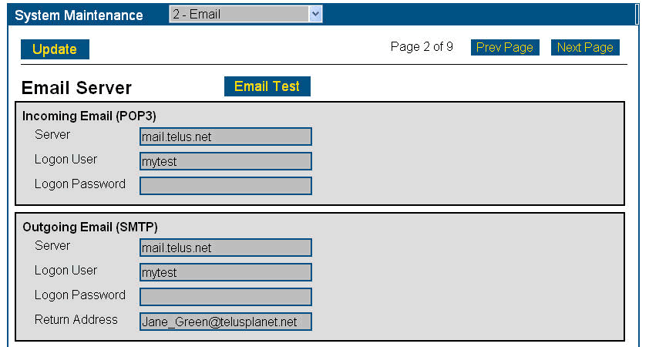
Figure 5-9 System Maintenance – Email Server
- Enter the required information according to the following table:
Table 5-5: System Maintenance/Email Server – Data Entry fields
Field | Description
Incoming Email (POP3):  server/logon user/logon password | POP3 is the only incoming email type Casper supports.  The name of the Server that handles incoming and outgoing email; the Logon User (either your user name or email address, depending on how the email server is set up); the Logon Password.
Outgoing Email (SMTP)  server/logon user/logon password/return address | SMTP is the only outgoing email type Casper supports.  The name of the Server that handles outgoing email; the Logon User (either your user name or email address, depending on how the email server is set up); the Logon Password; and the Return Address to which customers may reply.  This should be an email address that is checked by a human, such as a support group’s email address, and is usually different from the Casper server email address. Click Update to save the changes.  Note: The return email address must be filled in. Some email servers require it.
Note: The incoming email server logon user and the outgoing email server logon user may be different.
- Click Update to save changes.

E-Receipt
Page 3 – E-Receipt allows you to configure the Casper server to send automatic electronic receipts in response to successful credit card transactions made via Internet messages. Refer to Part 3: Casper e-Commerce for details.
For transactions made via email messages, separate electronic receipts are not issued. Instead, the receipt information is included in the standard confirmation email sent to the customer.

Licensing via Email
Page 4 – Licensing via Email allows you to send your customer authorization via email. You can force use of email authorization by not providing the URL for Internet-based authorizations in the Casper Wizard. As well, if the http: authorization fails, Casper will revert to email authorization automatically.
Procedure
- From the System Maintenance menu, select page 4 – Licensing via Email from the drop-down menu. The Licensing via Email page displays:
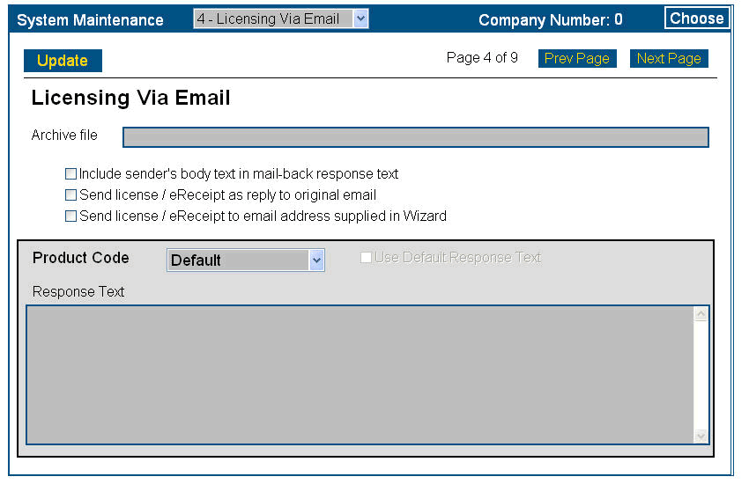
Figure 5-10 System Maintenance – Licensing via Email
- Enter the information according to the following table:
Table 5-6: System Maintenance/Licensing via Email – Data Entry fields
Field | Description
Archive file | Specify the full path for the log file to be written to.
Email options | Click the checkbox options that you require. Typically you should select the checkbox Send license/eReceipt to email address supplied in Wizard. If you select this checkbox, Casper will send the reply email to both the Server and the customer’s email address as entered in the Casper Wizard. If this option is not selected, the reply is sent to the originating email address.
Response Text/  Use default response text | Enter the response message to be sent to your customers when licensing your software via email. In your message, be sure to instruct your customer to enter the site key that Casper generates and sends with the reply email, in order to have their authorization completed. Check the box Use Default response text to use the default response text.
- Click Update to save your changes.

Easy License
Page 5 – EasyLicense allows you to instruct Casper to use a Normal license instead of EasyLicense in the event that EasyLicense fails (see Figure 3-40 Product Code Add screen). A Normal license is one defined by you with particular license restrictions. The Serial Number you use for authorization in Casper Wizard contains the license restrictions.
Procedure
- From the System Maintenance menu, select page 5 – EasyLicense from the drop-down menu. The EasyLicense page displays:
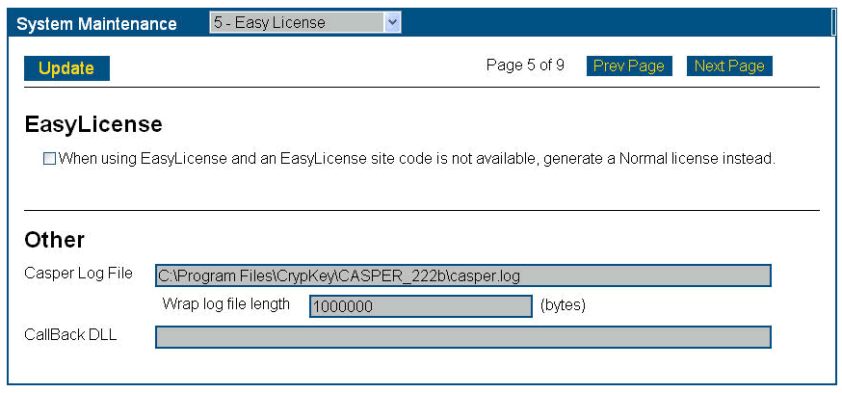
Figure 5-11 System Maintenance – EasyLicense
- Enter the information according to the following table:
Table 5-7: System Maintenance/Easy License – Data Entry fields
Field | Description
When using EasyLicense and an EasyLicense site code is not available, generate a Normal license instead. | Check to enable this feature. Casper must be able to read a site code HDSN in order to enable EasyLicense.
Others
Casper log file | This is the default directory and name of the Casper log file. You can change the directory where the log file will be stored. You can leave the log file blank, thus disabling event logging; however, this is not recommended. The log file is also useful to CrypKey Technical Support, should you need to seek assistance in resolving system problems.
Wrap log file length | Specify the size of the file before it rolls over. The file is a text file and does not contain proprietary or private information. Each event includes a timestamp. The Server truncates old data in order to maintain the log file at a maximum of 128 KB and prevent extremely large log files.
Callback DLL | The name of the DLL (Dynamically Linked Library). The DLL must be available in the Casper install directory. Input is optional. See Appendix A for more information on callback routines.
- Click Update to save your changes.

Auto Import
Page 6 – Auto Import allows you to import customer information in .csv or .xml files for entry into the Casper database (this is the quick alternative to manually adding the information via the Customer Add screen, see Add Customer Information on page 129).
Procedure
- From the System Maintenance menu, select page 6 – Auto Import from the drop-down menu. The Auto Import page displays:
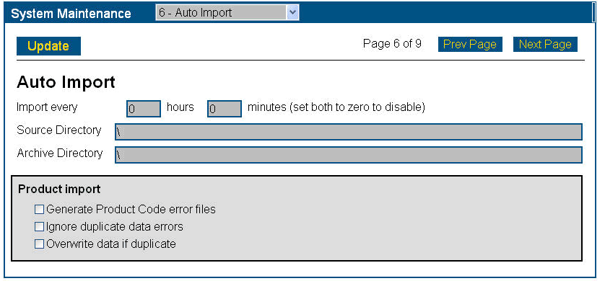
Figure 5-12 System Maintenance – Auto Import
- Enter the required information according to the following table:
Table 5-8: System Maintenance/Auto Import – Data Entry fields
Field | Description
Import every | Instructs the Casper Server to check periodically for import files. Set the import-file checking interval by hours and minutes. Set both hours and minutes to zero to disable.
Source directory | The full path to a directory where the import files will be extracted by the Server.
Archive directory (see Note below) | The full path to a directory where import files will be moved after being processed by Casper Server. Note: A log file (*.log) is also created in the Archive Directory for each file processed. If there is an error, an error file (*.err) is created in the Archive Directory. You should check the Archive Directory for error files, correct the corresponding import file, and copy the import file back to the Source Directory for reprocessing.  Error files and log files will be kept in the Archive Directory as well.
Product Import | General Product Code error files – this setting causes Casper Server to generate an additional error file in the archive directory, if there is an error in the Product Code.  Ignore duplicate data errors – this setting allows the import of duplicate data without generating an error.  Overwrite data if duplicate – this setting allows imported data to overwrite existing database data, even in cases of duplication.
Note: For details of constructing Casper data externally in a Comma-Separated Values (CSV) Auto Import file, see Appendix A: Technical References, CSV import file formats.
- Click Update to save your changes.
Chapter 6: Test Casper eRegister
Before processing live customer orders, we recommend you test Casper using your company data.
I
d

n Part 1:Setting up Casper, you tested Internet-based authorization requests from customers and issuing of licenses for your software; and also email authorization requests and issuing of licenses, using CrypKey-supplied test data. Now you need to repeat those tests using the live company data you entered (see Chapter 3: Managing Products and Chapter 4: Managing Customers).
Before testing Casper communications with your company data, you must first authorize the software.

Authorize your Casper Software
Refer to the following step-by-step instructions for licensing Casper.
To request your company-specific Casper files, send a request to authorize@crypkey.com asking for your company-specific Casper files. These files can only be obtained after CrypKey has received payment.
CrypKey will email you the following files:
- priv.key – encryption key that replaces the sample key installed with Casper
- pub.key – public encryption key to distribute to customers
- sk32mmtd.dll – site key generator dll customized for your company products.
Procedure
- Stop the web services using the statements:
net stop iisadmin /y
net stop CasperTimerService
net stop CasperV6
- Place the sk32mmtd.dll file in the Casper program directory.
- Copy the priv.key file to your Casper program directory.
- Put the pub.key file into the distribution that your client receives.
- Restart the web services using the statement:
net start w3svc
net start Casper TimerService

Test Casper Software using Company Data
Testing Casper eCommerce software follows the same process as in Part 1: Setting Up Casper, Testing Internet-based Authorization Requests and Issuing of Licenses . However, instead of using the test data, you will use your own company data.
Do not use the Client Test Program or the Simple Test Program, because you are now using your company-specific files sk32mmtd.dll, priv.key, and pub.key.
You must create and protect your own program to test with—for example, you can use your CrypKey-protected software (CrypKey Instant or CrypKey SDK) to run these tests. In order to use CrypKey Instant or CrypKey SDK, you must embed the Casper information into the protected software and be using the Casper Wizard. The following figure shows a sample of CrypKey Instant with Casper enabled.
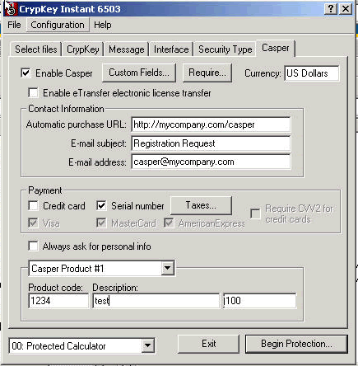
Check to enable Casper.
Enter Casper contact information.
Enter Casper Product Code and price (can be any value as it’s not used by Casper eRegister).
Figure 6-1 CrypKey Instant with Casper enabled
We recommend you repeat the entire test process that you performed with test data in Part 1, using your own data. This includes Testing Email Authorization Requests and Issuing of Licenses.

Chapter 7: Reports and Administration
Use CasperWeb to generate reports, and carry out administrative tasks.
A
d

dministrative and report functions are available in CasperWeb from the Main menu/Admin submenu.
Figure 7-1 Administration menu illustrates the menu you will access to carry out administrative and reporting functions in Casper.
Access Administrative functions from the Admin menu.
Figure 7-1 Administration menu

Admin Menu
The Administration menu offers these functions:
- Reports – this feature runs reports based on sales, authorizations, expired licenses or Serial Numbers.
- Exchange Rate – this feature applies to credit card authorizations only; see Part 3: Casper eCommerce.
- Change Password – this feature allows you to change the user log on passwords. (See User Maintenance on page 150 for information on setting up user passwords.)

Generate Reports
To generate various types of reports based on the data in the Casper database, refer to the following procedure.
Note: All reports are grouped by Product Code.
Procedure
- Go to the Main menu (see Log on to CasperWeb starting on page 68).
- From the Admin menu, click the Reports link. The Reports screen displays:
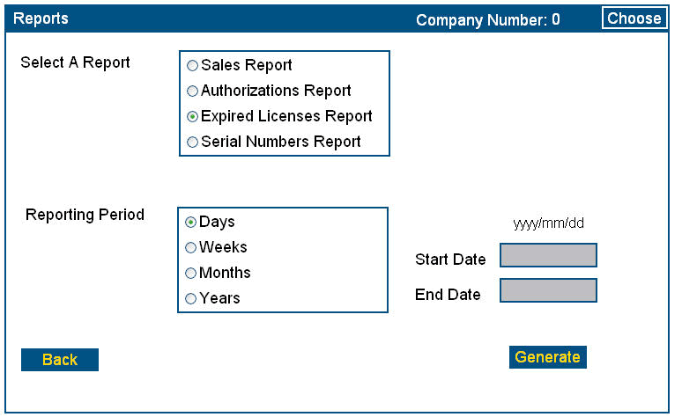
Select report type.
Enter reporting period, start and end dates.
Click Generate.
Figure 7-2 Reports screen
- Select a report type (Sales, Authorizations, Expired Licenses, Serial Numbers).
Note: Sales reports are normally used with the Casper eCommerce option, see Part 3 of this manual.
- Select a reporting period (days, weeks, months, years).
- Enter the start and end dates of the report in YYYY/MM/DD format.
For example: Start date: 2006/01/04, End Date: 2006/01/31.
Note: The start date cannot be later than the end date.
- Click Generate. The applicable report is displayed: in this example, expired licenses reported by day:

Reports are grouped by Product Code.

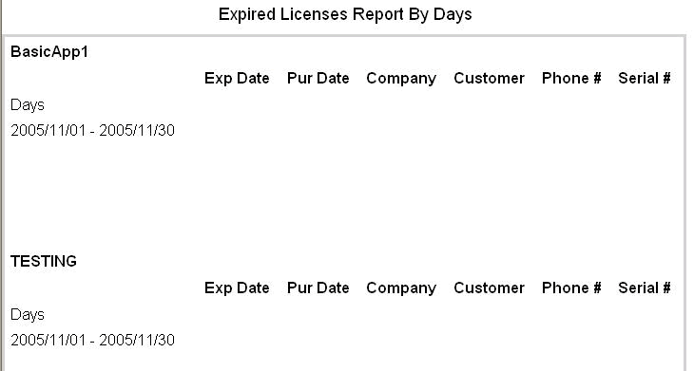
Figure 7-3 Expired Licenses Report by Day
- To print the report, right-click on the page and select the Print option.
Note: Some reports use a landscape orientation.
- The following figure shows a sample of Serial Numbers reported by day:
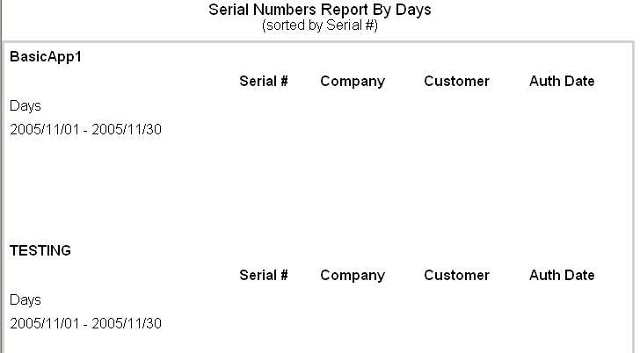
Figure 7-4 Serial Numbers Report by Day

Change User Password from Admin Menu
To change the password of a user, refer to the following procedure. The password is used for logging into CasperWeb.
Note: In order to be able to change passwords, you must be an administrator.
Procedure
You can change passwords from two menus: Admin/Change Password (shown below), or as a function of the SuperUser menu/User Maintenance option.
- From the Main menu, click on the Change Password link in the Admin menu. The Change Password displays:
Select user.
Enter password, and re-enter to confirm.
Click OK.
Figure 7-5 Change Password – from Admin menu
- Select the user from the drop-down list for the User field.
- Enter the user’s new password.
- Retype the password.
- Click OK.
Index
This index includes page references for significant occurrences of Casper topics and terms in Part 2.

add customer
required fields 131
Casper
system requirements 68
Casper software
test with your data 168
CasperWeb
definition 149
features 63
functions 65
prerequisites 63, 66
CrypKey Instant 85
CrypKey SDK 85
customer
add to Casper database 129
history 140
information 65
developer keys 76
EasyLicense 163
encryption key 167
for customers 167
error messages 73
exception error message 73
executables 93
file name 117
version 98
function buttons 71
import
customer information automatically 165
Keys Used/Limit 143
license
issuing procedure 67
multi-company 70
license restrictions
and Product Codes 67
license type
add 112
licensing
your Casper software 167
log off 71
log on 68
Main menu 71
option bit 108
options and levels 65
password
ODBC database 159
product
and number of versions 82
delete information 90
families 76
information 65, 75
information modification 86
number 84
Product Code 66
add 115
associate with executable 118
delete 126
vs. product 76
Product Code Browser 118
renewal license 135
reports
by sales 173
by serial number 174
generate 172
search
for customers 137
Serial Numbers 67
and customers 119, 129
and Product Codes 115
references customer records 137
vendor supplied 67
Site Code 69
Site Key 66
generation 140, 142
Site Key Generator 66
dll 167
software
authorizationmethods 67
vendor 67
verification 67
SuperUser 150
system maintenance
functionality 156
menu 156
system requirements 68
technical support 73
test data 167
user
add 150
delete 153
web services
restart command 168
stop command 167

